A Second Look at
Fabricating Impedance Transformers
for Receiving Antennas
John Bryant with Bill Bowers and Nick Hall-Patch, VE7DXR
DXing.info, July 2003

Author's Note
When I wrote the first version of this article in May 2001, based on the state-of-the-art and manufacturers recommendations, I never expected to have to rewrite it with totally new recommendations. That is what has happened. In the fall of 2002, I happened to be discussing transformers with by close friend Bill Bowers and he indicated that he really wasn't sure the winding pattern that I had been recommending for impedance transformers was anywhere near the most effective. That shook me, because I knew that Bill had spent his career dealing with low levels of AC current and magnetism and I knew that he had recently completed a major research project and had just published articles on impedance transformers for use at long wave frequencies. A rather intense discussion followed and, happily, Bill volunteered to undertake the same kind of laboratory-grade study of impedance transformer designs hoping to develop an ideal transformer for medium wave and the lower shortwave frequencies. Nick Hall-Patch, VE7DXR, the Technical Editor of IRCA, also lent his expertise to the subject. The ensuing joint project took almost all of our individual hobby time during the 2002-2003 DX Season and resulted an a recently published 26-page article that, to say the least, goes into far more detail than most people would ever want to know about this rather arcane subject. That article is available as an auto download (MS Word format) to anyone who is interested at (http://dxing.info/equipment/impedance_matching_bryant.doc). The following is a rather thorough update of my original fabrication article.

Why Should You Roll Your Own???
With the proliferation of local neighborhood noise sources and the growing popularity of wire antennas in configurations other than the inverted L, coaxial cable has become the antenna lead-in of choice for most radio hobbyists. Since the impedance of most commonly available coax is either 50 or 72 ohms and since many wire antennas exhibit impedance of 400 to 1000 ohms or more at the feed point, directly connecting the coax to a wire antenna invites very significant signal losses due to the impedance mismatch. Given this situation in the listening hobbies, it has been a mystery to me why impedance transformers and baluns for receiving antennas have not been more commonly available on the retail market. Further, the few transformers that are available are offered at around $60.00. While this may be a fair price, considering labor, profit and retail mark-up, the parts cost for a good weather-tight balun or impedance transformer is well under $10, paying retail for the parts! If you own a soldering iron and can make even a semi-reliable connection, you really ought to consider "rolling your own" baluns and transformers. The total labor time is about one hour per unit and the construction is quite simple. Personally, I make mine in front of the TV on Sunday afternoons. Essentially, while making transformers, I'm paying myself $50 per hour to watch the Dallas Cowboys have yet another terrible season. Not a bad deal, at all.
All of the impedance transformers with which I am familiar are based on some sort of ferrite core with windings around it. Several well-known East Coast DXers favor manufactured transformers from Mini-Circuits and just wire this tiny transformer in the appropriate box and add connectors. The very small 9-to-1 Mini-Circuit transformers are perfect for converting the 450 ohms of beverages and many other wire antennas to 50 ohm coax. I used these small units for several years, before swearing off them entirely. DXing on the prairies North America generally exposes wire antennas to a good bit of static electricity. Both Bill Bowers and I had several random failures of the Mini-Circuits units, probably due to the hair-small wire used to wind the transformer. The main problem was that the failures were often partial, making us think - for several nights running - that conditions were really bad. What a waste! After the third such failure, I returned to the tried-and-true "roll your own" techniques based on relatively larger ferrite toroids. These techniques were originally taught to me over a decade ago by Nick Hall-Patch and published in a co-authored article in Fine Tuning's Proceedings 1988.

Recommended Transformer Design
Once the decision is made to roll your own using ferrite toroids, there are several more decisions to make: the size of toroid and the specific ferrite mix to be used, the design of the winding pattern and the turns count. When Bill Bowers, Nick and I started our 2003 project, we thought that we would be recommending several designs, based on the frequency band that a DXer is interested in. As work went along, Bill began to focus on a single broadband design that would perform adequately on long wave, superbly between 500 kHz. and 5 MHz., and reasonably well for a ways above that. This later broadband design became the design goal of our project

Toroid Size
In North America, at least, most of us use the toroids from Amidon. These may be purchased over Internet directly from the manufacturers at (http://www.amidon-inductive.com/associates_prod_toroidal.htm). Most of us use one of three sizes of cores. The smallest that is commonly used by homebuilders is a 1/2" diameter toroid (Amidon's FT-50) that looks like a half-eaten Life Saver candy. To get the proper turn count through the donut hole, you must use very fine magnet wire and a large needle. I have found working with FT-50 to be overly fussy and I've also become concerned about static electricity burning the very thin wires. I see no advantage in using cores this small and I don't recommend them now. The largest toroids that I've used measure 1.4 inches in diameter (FT-140.) These work, but they are a little heavy and expensive. Our study recommends the middle sizes, 1.14 inch or .82 inch diameter donuts, that are large enough to handle easily. We also used 30 gage Kynar insulated wire is our study (Radio Shack # 278-501, 502 or 503 and from most major parts houses.) This wire is small enough to make a neatly wound coil of the proper turns-count on the toroid and yet the wire is large enough and stiff enough to be easy to handle.

Ferrite Mix
The two ferrite mixtures most often recommended for this application are Type 43 and Type 75. Bill Bowers' initial round of testing investigated these and Type 61. After building and [precisely] testing over 50 transformers, the determination was made that Type 75 performed the best for the "ideal" broadband transformer operating over LW, MW and the lower shortwave frequencies.

Winding Pattern
The most controversial aspect to designing impedance transformers is the pattern of winding the two coils of the transformer. There are two camps:

- Those who favor two individual close-wound coils, separated as far as possible on the circumference of the donut. These designers are most concerned about capacitive coupling between the two coils - essentially partly short-circuiting the transformer - and trust the toroid to guide all of the signal energy from one coil to the other. (We referred to this type winding as "SS" in our study.)

- Those who favor thoroughly merging the windings of the primary and secondary coils, either by using patterns called "tri-filar" or "quadra-filar" (TW) or by using more traditional "over-lapped" (OL) winding achieved by first laying down the larger coil, spread entirely around the circumference of the toroid and then winding the smaller coil atop the larger, again spread around the entire circumference of the coil. This latter group of designers believes that the toroid cannot be trusted to carry all of the energy from the primary to the secondary in the separate-and-close-wound(SS) design and feel that the losses due to inter-coil capacitance to are much less than those due to the inefficiency of the toroid itself (leakage inductance losses) in the SS pattern.

Bill's comparative studies indicated that there was not much difference in performance between the winding types at medium wave frequencies. However, as one moves above about 2 MHz, the leakage inductance losses became very serious in the SS design and the difference in losses between the separate winding and merged winding designs sometimes approached 4 dB! Field tests not only confirmed these findings, but indicated that they were quite conservative. Therefore, we recommend the "traditional" overlapped windings for our design.

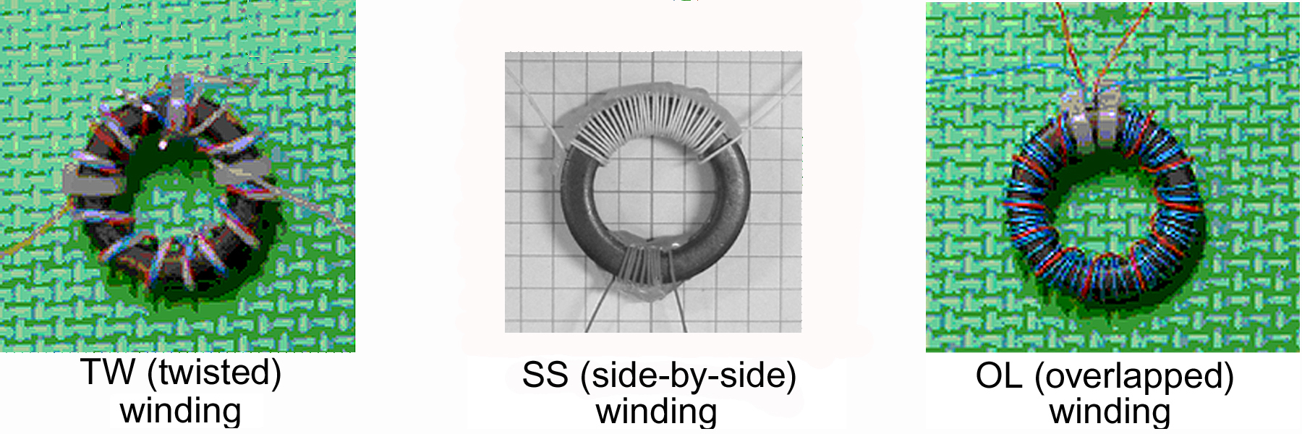

Turns Count
For designing impedance transformers to operate at a specific range of frequencies, the number of turns for the primary and secondary are usually determined by a standard set of formulae that are available in most texts and from the toroid manufacturers. However, Bill Bowers' previous study of impedance transformers for long wave reception indicated that a turns count almost 50% higher than that generated by the standard formulae was more efficient. One of the primary purposes of our in-depth study was to test transformers across a range of turns counts to determine whether the standard formulae were totally accurate for this application.

We found that, for this frequency range, the formulae were more nearly correct than for a narrow-band design at long wave frequencies. However, our "ideal" design - determined by direct experimentation - was still at slight variance to conventional wisdom.

Recommendations
For 450 ohm to 50 ohm conversion (Beverage antennas, etc.):

Size: Either FT-82 or FT-114

Material: Either Type 75 or Type J

Winding Pattern: Either quadra-filar (TW) or traditional overlapped (OL) windings
Turns Count: 11/33 (The 11 turn coil goes to the coax, the 33 turn coil to the antenna.)

For 900 ohm to 50 ohm conversion (flags, pennants, KAZ loops, etc):

Size: Either FT-82 or FT-114

Material: Either Type 75 or Type J

Winding Pattern: Either quadra-filar (TW) or traditional overlapped (OL) windings
Turns Count: 11/48 (The 11 turn coil goes to the coax, the 48 turn coil to the antenna.)

Detailed Findings
For the actual loss figures for these recommended transformers, refer to the Appendix to this article. For a thorough (26 page!) report on out entire experiment/transformer design project, refer to "Impedance Matching Transformers for Receiving Antennas at Medium and Lower Shortwave Frequencies" by Bill Bowers, John Bryant and Nick Hall-Patch, VE7DXR. This is available on-line at (http://dxing.info/equipment/impedance_matching_bryant.doc)

For Other Impedance Ratios
If you have an antenna-to-lead-in arrangement with different impedances then you can use the following equation to determine the number of turns required, so long as the core and these same frequency ranges (500 kHz. to 5 MHz., with reasonable performance above and below those boundaries) are held constant:
N2 = N1 √R2 / R1
If you decide to use the 11 / 33 winding ratio but you have a 75-ohm receiver or cable connection, then adjust the 11 turns as follows:
N1 = 11 ; R2 = 75 ; R1 = 50
N2 = 11 √ 75 / 50 = 11* 1.22 = 13.47 = 14
If you have a 50-Ohm receiver input but a 600-Ohm antenna, then adjust the 33 winding in the same way.
N1 = 33 ; R2 = 600 ; R1 = 450
N2 = 33 √600 / 450 = 33 * 1.154 = 38.10 = 38

In Use
Selecting Components
Having created the guts of the transformer, you now need to obtain some connectors and a weather-tight box. For the wire connectors, I have come to use the type of binding posts that also accept a banana plug in the top of the post and also work as conventional wrap-around/screw-down binding posts. That way I have several choices of connection methods at the antenna. These parts are all available at Radio Shack. I have fallen in love with one special form of banana plug, though, that is only available from professional parts houses (Mouser #17HR549, #17HR550). The shaft of the male plug has a stiff wire running down it and it makes a VERY reliable connection by actually plowing a shallow furrow in the metal of the female banana socket. The connector for the coax is a normal chassis-mount coax connector of your particular flavor. More and more hobbyists seem to be switching to BNC connectors for their ease of use and better weather characteristics, though only professional-class receivers yet use this type.

Some DXers swear by all-metal boxes for housing impedance transformers. If you fall into this camp, the cast aluminum Hammond boxes are my choice. I buy mine through Antique Electronics Supply (http://www.tubesandmore.com/). Those who use metal boxes are usually attempting to maintain the system as RF sanitary as possible, preventing stray signal pick-up by grounding the box, usually to the coax shield. However, the majority of DXers I know, and most manufacturers, use cast plastic enclosures. They reason that the stray signal pick-up is miniscule, compared to the size of the antenna, and let the ease of using the plastic boxes, and their significantly lower cost, make that decision for them. Personally, if I'm in one of my rare obsessive/compulsive phases, I use metal; if I'm "normal," I use plastic. I've never been able to distinguish between the two designs in actual use.
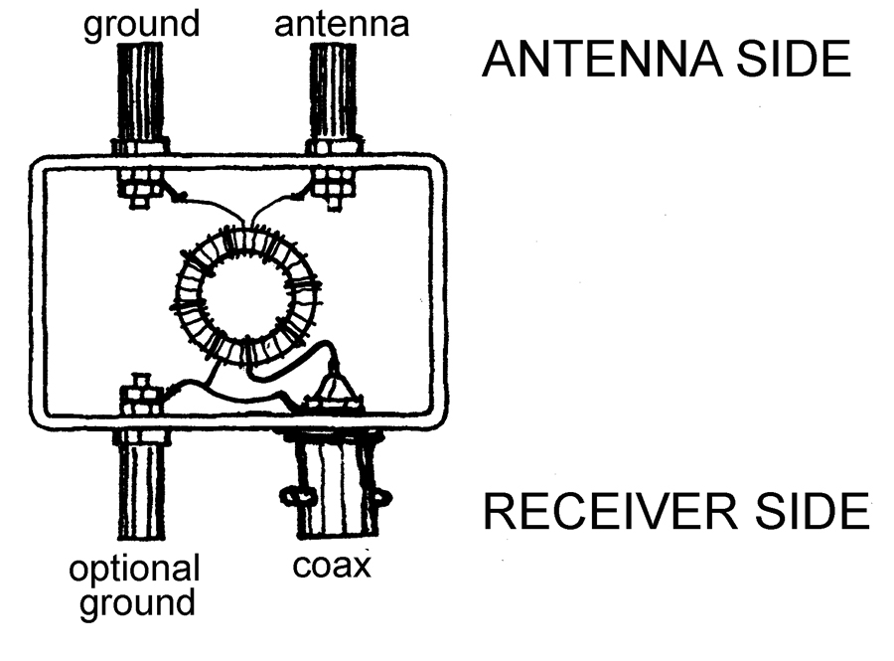

I like to install an optional binding post ground on the receiver side of the box. This allows me the ultimate flexibility in installing the transformer in the field. For instance, it is about the only way to easily install the transformer in the Circuit C and Circuit D configurations listed below. If you don't need this flexibility, leave that binding post off and simply attach one side of the receiver coil to the center of the coax fitting and the other to the shield side.

About all that we have left to discuss is various arrangements for placing the transformer between your antenna and coax. Unfortunately, it is at this point that we leave the world of science and begin to deal with sorcery. It turns out that there are a lot of ways to hook these things up, and most of the controversy centers on various grounding schemes. There are two main circuits to discuss:

Single Wire Antennas
There are three or four choices of circuit arrangements here and the best one for your application probably should be determined by careful experimentation. The "scientifically superior" arrangement is probably that shown here as "Circuit A." The second side of each of the coils is connected separately to ground. Signal current and static electricity flows from the antenna through the larger coil directly to ground. Current between ground and your receiver is induced into the smaller coil. The main argument against Circuit A is that individual grounds must be separated by at least 12 to 15 feet to be electrically separate, or so I've read. Due to connection through the ground itself, what is probably being accomplished, electrically, with Circuit A is actually Circuit C. Circuit B is the one that Nick Hall-Patch has used with excellent results for years. Grounding of the coax shield, if any, is accomplished at some distance from the transformer.

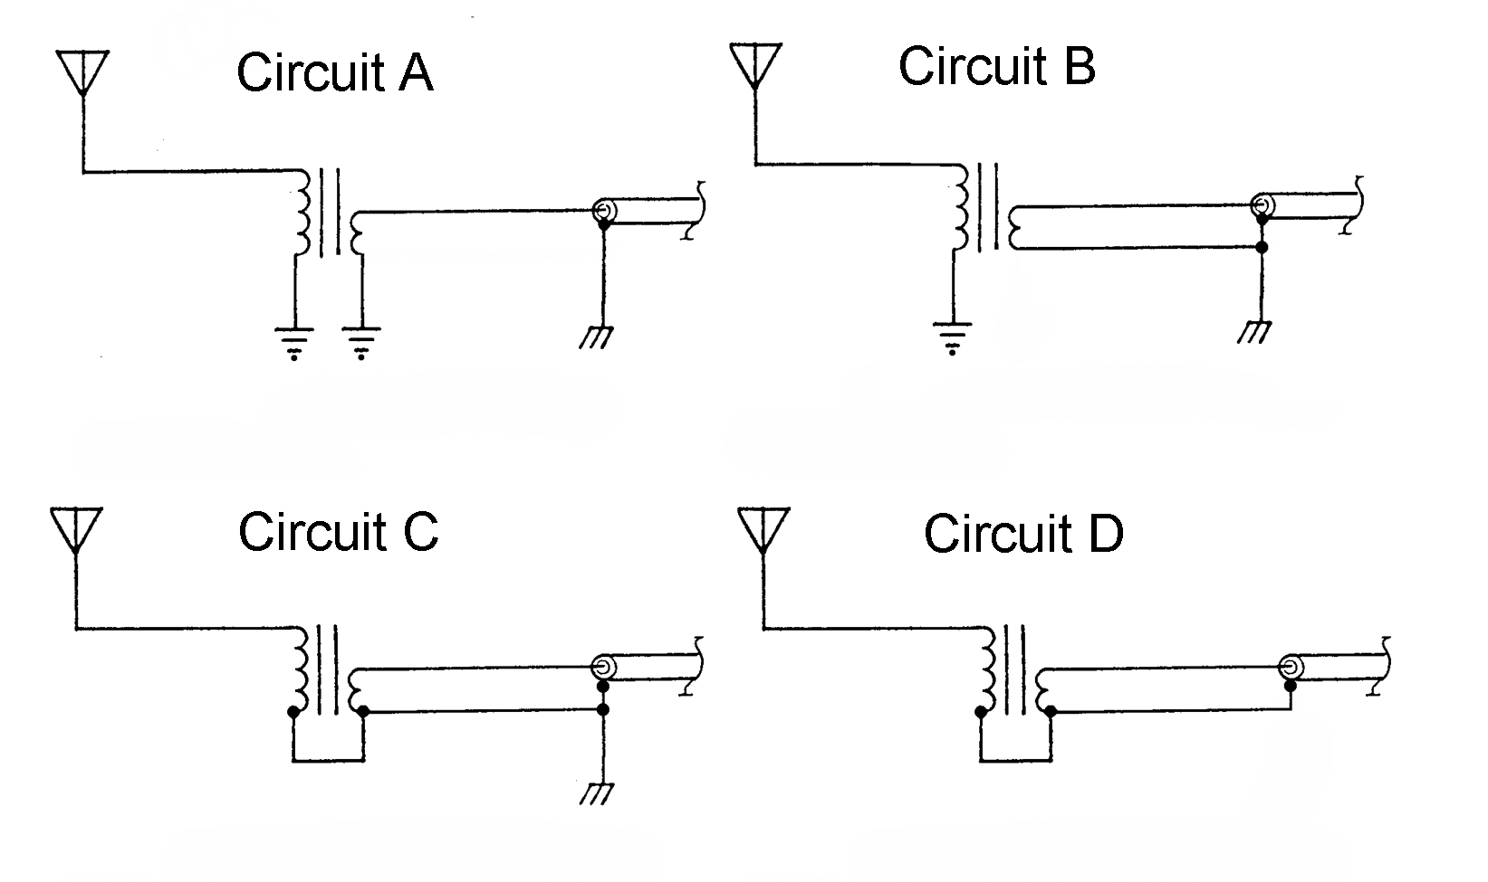

Circuit C recognizes the problem of possible interaction between the two "separate" grounds and simply connects the grounded side of both coils and the coax braid to a single ground at the antenna feed point. This is the circuit that I use when the feed point of the antenna is within three or four feet of the ground and the grounding conditions are good. After writing this article and having Nick pound his approach through my thick skull yet one more time, I think I'll be switching my approach to Circuit B.

Circuit D is the arrangement that the "magnetic balun" manufacturers normally use. The grounded sides of the coils are connected together and hooked to the braid of the coax. The grounding that is so vitally necessary for signal flow is accomplished through the coax braid and left totally to the user. This is the circuit that I use for random wire antennas and I ground the braid at least once between the antenna and the receiver. I will confess, though, that I've used Circuit D with good success on occasion with an ungrounded coax and an ungrounded receiver. I know that I'm taking a chance with static electricity build-up, and I wonder whether all of the signal energy is reaching my receiver; but there you are: my guilty little secret.

Loops
Luckily, with loops like the KAZ delta, etc., things are fairly straightforward. The larger coil of the transformer is connected directly (in series) into the loop. One side of the smaller coil is connected to the center conductor of the coax. The other side of the smaller coil may be connected to the coax braid, may be grounded, or both. If the loop feed point is within a foot or so of the ground, it is probably best to ground the second side of the smaller coil. However, if you have a poor grounding situation, or the feed point is in the air, the smaller loop ought to just be connected to the coax braid.

Closing remarks
About the only issue left to mention is physically attaching the transformer to the interior of the box. I'm rather sure that most constructors will have a favorite method. Mine is to simply hot glue the transformer securely to the plastic box. In some cases, I have even totally encapsulated the transformer in hot glue. I have sometimes wondered if I wasn't somehow affecting the magnetic qualities of the transformer with the hot glue. Bill Bowers has run some quite sophisticated bench tests concerning this and assures me that the qualities of the transformers are unaffected by hot glue.

Well, there you have it. For those of you interested in making $50.00 per hour rolling your own matching transformers while watching your favorite sports franchise get blown away yet again, order some cores, make a quick trip to Radio Shack or your junque box and HAVE AT IT.

May the forces (magnetic) be with you!

Appendix

During Bill Bowers' laboratory tests, he was considering two types of losses. The first of these is "insertion loss" which occurs internally within the transformer and which was the main focus of out study. A second form of loss occurs when part of the signal energy is reflected back into the antenna. This form of loss can be derived mathematically and is known as "loss due to SWR." When the SWR is greater than 1:1 then part of the signal from the antenna is reflected back to the antenna and never gets into the transformer. The total loss of the available signal from the antenna is therefore the sum of the “ insertion loss “ and the effective “loss due to the SWR”. As long as the SWR is in a reasonable range, ( below 1:1.5, SWR loss = 0.17db ), the insertion loss is really all that needs to be considered. At higher SWR values, the SWR loss can become significant. Those relatively small losses were found to be as follows:

SWR | 1:1 | 1.5 | 2.0 | 2.5 | 3.0 | 3.5 | 4.0 | 4.5 | 5.0 | 5.5 | 6.0 | 7.0 | 8.0 | 9.0 | 10
-db | 0 | 0.17 | 0.51 | 0.88 | 1.2 | 1.6 | 1.9 | 2.2 | 2.5 | 2.8 | 3.1 | 3.5 | 4.0 | 4.4 | 4.8

Our major study presents a large number of insertion loss findings for the transformer designs that were investigated. Here, we include only the final insertion loss studies. The first two tables represent the insertion losses for the final 450-ohm to 50-ohm transformer designs. The third chart details the losses in the FT-114-75 design that was recommended in the previous version of this article.

 | FT-114-75 |  |  |  |  | FT-82-75 |  |  |  | FT-114-75
 | Windings: 11/33- OL |  |  |  |  | Windings: 11/33-OL |  |  |  | Windings: 4 / 13-SS
.freq | Z | angle |  | SWR | Loss | Z | angle | SWR | Loss | Z | angle | SWR | Loss
MHz | ohms | deg. |  |  | -db | ohms | deg. |  | -db | ohms | deg. |  | -db
0.1 | 439 | 12.0 | 1.24 |  | 0.14 | 425 | 15 | 1.31 | 0.24 | 278 | 57.5 | 3.90 | 2.9
0.3 | 444 | 4.0 | 1.07 |  | 0.09 | 435 | 4.9 | 1.09 | 0.16 | 436 | 26.6 | 1.62 | 1.00
0.5 | 444 | 2.7 | 1.05 |  | 0.10 | 434 | 3.1 | 1.06 | 0.17 | 452 | 18.9 | 1.39 | 0.85
0.7 | 444 | 2.3 | 1.04 |  | 0.11 | 434 | 2.6 | 1,06 | 0.17 | 458 | 17.1 | 1.35 | 0.84
0.9 | 444 | 2.2 | 1.04 |  | 0.11 | 434 | 2.4 | 1.06 | 0.18 | 463 | 17.0 | 1.35 | 0.85
1.1 | 444 | 2.2 | 1.04 |  | 0.11 | 434 | 2.3 | 1.06 | 0.18 | 469 | 17.6 | 1.37 | 0.86
1.3 | 444 | 2.3 | 1.04 |  | 0.11 | 434 | 2.4 | 1.06 | 0.18 | 475 | 18.5 | 1.39 | 0.86
1.5 | 444 | 2.4 | 1.05 |  | 0.11 | 434 | 2.4 | 1.06 | 0.18 | 482 | 19.6 | 1.42 | 0.93
1.7 | 444 | 2.5 | 1.05 |  | 0.12 | 434 | 2.5 | 1.06 | 0.18 | 489 | 20.8 | 1.46 | 0.98
1.9 | 444 | 2.7 | 1.05 |  | 0.12 | 435 | 2.6 | 1.06 | 0.18 | 495 | 22.0 | 1.50 | 1.04
2.1 | 444 | 2.8 | 1.05 |  | 0.12 | 435 | 2.7 | 1.06 | 0.18 | 503 | 23.3 | 1.54 | 1.11
3.0 | 445 | 3.7 | 1.07 |  | 0.15 | 436 | 3.3 | 1.07 | 0.19 | 542 | 29.2 | 1.76 | 1.47
4.0 | 446 | 4.8 | 1.09 |  | 0.17 | 437 | 4.1 | 1.08 | 0.20 | 600 | 35.0 | 2.05 | 1.97
5.0 | 448 | 5.9 | 1.11 |  | 0.19 | 439 | 5.0 | 1.10 | 0.21 | 671 | 39.5 | 2.38 | 2.36
6.0 | 452 | 7.0 | 1.13 |  | 0.21 | 441 | 5.8 | 1.11 | 0.22 | 752 | 42.7 | 2.72 | 2.79
7.0 | 456 | 8.1 | 1.15 |  | 0.23 | 444 | 6.7 | 1.13 | 0.22 | 840 | 44.8 | 3.06 | 3.18

Note the relative evenness of performance of the two new designs over the frequency range. Neither impedance nor insertion losses vary a great deal. Compare these results, then, to the losses of the previously recommended design with 4/13 turns. The poor performance of the old design at the low end of the spectrum is due to the fact the previous design was only intended for use above 500 kHz. and therefore just had too few turns for long wave. The losses and the rather staggering changes in impedance above 2 MHz. are due to leakage reactance brought on by my use of widely separated windings (the SS pattern.) It is important to remember that these insertion losses must be added to the "losses due to SWR" detailed above. Therefore the total losses of the old design at 7 MHz. are about 4.4 dB. Field tests using Beverage antennas in the spring of 2003 indicated that the comparison of the two designs around 5 MHz. sometimes approached 10 dB advantage for the new design.

The following two charts detail the insertion losses for the final 900-ohm to 50-ohm designs:

 | FT-82-75 |  |  |  | FT-114-75
 | Windings: 11/48-OL |  |  |  | Windings: 11/48-OL
.freq | Z | angle | SWR | Loss | Z | angle | SWR | Loss
MHz | ohms | deg. |  | -db | ohms | deg. |  | -db
0.1 | 919 | 14.2 | 1.28 | 0.19 | 927 | 12.1 | 1.24 | 0.14
0.3 | 926 | 4.5 | 1.08 | 0.14 | 937 | 3.6 | 1.07 | 0.10
0.5 | 924 | 2.8 | 1.06 | 0.15 | 935 | 2.0 | 1.05 | 0.11
0.7 | 924 | 2.1 | 1.05 | 0.16 | 935 | 1.4 | 1.04 | 0.11
0.9 | 924 | 1.7 | 1.04 | 0.16 | 935 | 0.9 | 1.04 | 0.12
1.1 | 925 | 1.5 | 1.04 | 0.16 | 935 | 0.7 | 1.04 | 0.12
1.3 | 926 | 1.4 | 1.04 | 0.16 | 936 | 0.5 | 1.04 | 0.13
1.5 | 926 | 1.3 | 1.04 | 0.16 | 936 | 0.3 | 1.04 | 0.13
1.7 | 927 | 1.2 | 1.04 | 0.16 | 936 | 0.2 | 1.04 | 0.14
1.9 | 928 | 1.2 | 1.04 | 0.16 | 936 | 0.1 | 1.04 | 0.15
2.1 | 929 | 1.1 | 1.04 | 0.16 | 936 | -0.2 | 1.04 | 0.15
3.0 | 933 | 1.0 | 1.04 | 0.17 | 938 | -0.4 | 1.04 | 0.18
4.0 | 937 | 1.1 | 1.05 | 0.19 | 943 | -0.6 | 1.05 | 0.21
5.0 | 942 | 1.1 | 1.05 | 0.21 | 952 | -0.9 | 1.06 | 0.28
6.0 | 949 | 1.2 | 1.06 | 0.23 | 964 | -1.3 | 1.08 | 0.30
7.0 | 958 | 1.2 | 1.07 | 0.25 | 977 | -1.8 | 1.09 | 0.35

