Thailand Approach to Bridge the Digital Divide: the Role of Telecenter
presented at
APEC Telecenter Training Camp
24-29 January 2005, Taipei, Taiwan

Kasititorn Pooparadai,
National Electronics and Computer Technology Center, Ministry of Science and Technology
Somboon Mekpaiboonwattana, Wirun Tharmmapornphilas
Ministry of Information and Communication Technology

I. Introduction
The recent World Summit on Information Society has reinforced the role of Information and Communication Technology (ICT) in harnessing the development as specified in the Millennium Development Goals. In the declaration of principles, world leaders declare
“common desire and commitment to build a people-centred, inclusive and development-oriented Information Society, where everyone can create, access, utilize and share information and knowledge, enabling individuals, communities and peoples to achieve their full potential in promoting their sustainable development and improving their quality of life”
However, the main obstacle facing the visionary Information Society is that of the Digital Divide, the gap between those who can have access to and gain benefit of ICT and those who cannot. The divide, which is caused by a number of influential factors including location, income, education, physically constraints etc., exists both between nations and within the nation. And unless the gap is narrow, only the privilege few are able to reap the benefit of ICT, the rest will be further marginalized.
This paper highlights the situation of the digital divide in Thailand, with particular emphasis on the gap between people who live in urban and rural areas. First, we illustrate the unequal diffusion of ICT in the country. Then we sketch government general policies and initiatives to bridge the digital divide. Lastly, we discuss the existence, or lack of, Telecenters in Thailand and their role in bridging the digital divide.

II. Digital Divide in Thailand
The digital divide can be measured via several indicators. We put forward here the three often-cited indicators: telecommunications infrastructure, computer and Internet usage. Regarding telecommunications, in recent year we have witnessed the extraordinary growth of mobile phone. Its penetration rate has now reached 36.3% and surpassed that of fixed-line, which stood at approx. 10% (Figure 1).

Figure 1 Teledensity in Thailand: Fixed line vs. Mobile (1999-2004)
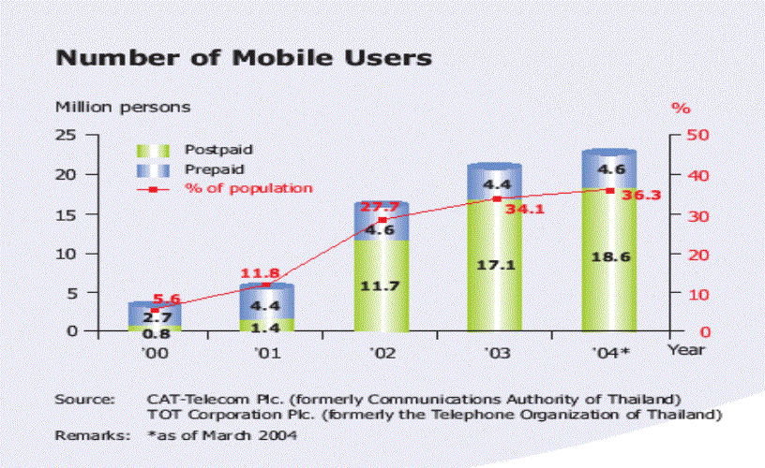

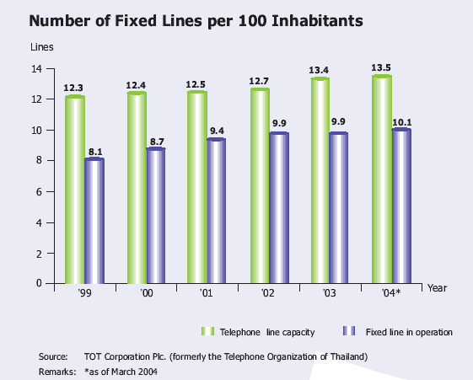

In addition, there has been a great disparity in access to telephone services between urban and rural population. In terms of fixed lines in operation, there were nearly 40 lines per 100 populations in Bangkok and vicinity in 2004. The number decreased dramatically to around 5.5% when considered the rest of the country (Figure 2). Meanwhile the gap in mobile penetration was somewhat narrower, yet the divide prevails.

Figure 2. Fixed lines in Operation per 100 Inhabitants: Bangkok vs. Rural

Figure 3. Mobile subscribers per 100 Inhabitants by Location (2003)

With regards to computer diffusion, 2003 marked the proliferation of computers in Thailand as a result of government intervention – the “low cost PC” initiative. The project made available PCs and software at affordable price to general publics. Nevertheless, the digital divides still prevails, with households and business establishments in Bangkok have better access than those in other regions. As for Internet usage, there were nearly 7 million Internet users in 2004, of which 2 millions or 29% concentrated in Bangkok. Around 26% of people who live in Bangkok use Internet, whereas Internet users constituted merely 7.7% of Northeastern population. (Table 1).

Table 1
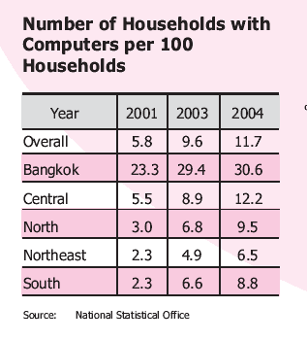
Table 2

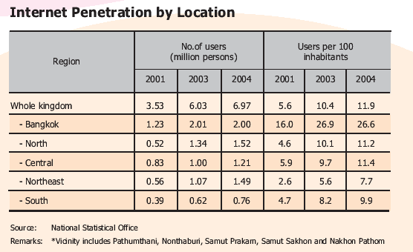

III Bridging the Digital Divide: Thai Approach

Thailand approach towards bridging the digital divide can be categorized into three levels: legislations which provide foundation for the development of equitable information infrastructure; policies and plans directed at bridging the digital divide or ensure the access to information infrastructure and, initiatives and projects turning the policies into implementation. We discuss them in turn.
(i) Legislation
- At the highest level, the Constitution of the Kingdom of Thailand 1997 article 78 specifies the state’s responsibility in providing equitable information infrastructure throughout the country in order to facilitate decentralization process.
- The Act on the Organization to Assign Radio Frequency and to Regulate the Broadcasting and Telecommunication B.E. 2543 (2000), here after referred to as Frequency Allocation Act, instigates the establishment of two independent regulatory bodies i.e. the National Broadcasting Commission (NBC) and the National Telecommunications Commission (NTC). The Act grants the two bodies authority to establish and enact measures necessary to the development of equitable information infrastructure. Besides, the Act specifies the need to set up “public benefit fund” to support the overall operation for public services.
- The Telecommunication Business Act B.E. 2544 (2001) authorizes the NTC to administer the universal service obligations for basic telecommunications services and to prescribe licensees to provide telecommunication services to rural area, educational institutions, religious institutions, medical agencies institutions and other social assistance agencies as well as to facilitate the use of public telecommunications service for disabled, children, senior citizen, and under-privileged.
- The National Education Act B.E. 2542 (1999) recognizes the role of technologies for Education and dedicates one chapter solely for this issue. Article 63 states that state shall distribute frequencies, signal transmission devices, and other infrastructure necessary for radio broadcasting, television, telecommunication radio and other media of communication for use in provision of formal, non-formal and informal education and enhancement of religious, artistic, and cultural affairs as necessary. Besides, article 64 focuses on mobilizing financial resources for the establishment of the Technology for Education Development Fund. These resources shall include state subsidies, concession fees and profits from enterprises relating to mass media and information and communication technologies from all sectors concerned, namely, state sector, private sector, and other public organizations.

(ii) Policy
- In IT 2010, two flagships concerning social development were devised: e-Society and e-Education. E-Society states clearly the threat of digital divide on the nation competitiveness as well as leading to deterioration of human resource development, which might tarnish the long-term development. This recognition leads to strategies to (a) develop an equitable national information infrastructure with action such as accelerating telecommunications reform and allocate radio frequencies for public interest and (b) create digital opportunity and bridge the digital divide focusing on information and knowledge over modern technology and supporting the establishment of community access center, from which all people have equal access.
Similarly, e-Education include strategies to (a) develop an information infrastructure for education as well as to (b) create educational content and knowledge which include promoting and supporting research and development and the creation of the software industry and the production of educational multimedia.
- The 2nd strategy of the National ICT Master Plan 2002-2006 aims at utilizing ICT to enhance the quality of life. To accomplish this, basic information infrastructure where all Thai people can have equal access needs to be in place. Not surprising, a number of measures and goals target directly at expanding the telecommunications infrastructure, for examples: (a) provision of at least seven telephone numbers (32 kbps minimum) in every community (village) by 2005; (b) giving at least 70% of low income earners access to ICT services by 2006 and; (c) having a community Telecenter in every sub-district by 2006.

(iii) Projects/Initiatives: examples
- SchoolNet project, initiated as a pilot project by NECTEC in 1995, aimed to link 5,000 schools nationwide to the Internet, so as to ensure equal educational opportunities to all Thais. In addition to providing access, the project also included other elements such as content creation and teacher training. Ministry of Education, who has been in charge of the project since the beginning or 2003, is now expanding this into full-scale implementation.
- Affordable PCs: three projects can be classified as contributor to make affordable PCs to general publics
  - Economy-Class PC: In 2001, NECTEC created a cluster of computer manufacturing companies who were participating in NECTEC Quality PC Certification Project to produce a popular PC model, which cost less than approximately US$500. This is to promote the widespread use of ICT, which will increase the opportunity to develop further the country’s pool of knowledge, education, economy and society.
  - ICT Budget PC: MICT who initiated and managed the project aimed to reduce the digital divide by increasing the number of computer users with ultra low-price PCs of around US$250. The PC specifications are for general use for the office, home and schools, with Internet access and multimedia capability. The project has stimulated greater demand for PCs in Thai market as well as induced competition among firms who participated in the project and those who are not. Around 160,000 was estimated to be ordered and. delivered, leading to subsequent project
  - The ICT PC Project for Children is the latest of a series of highly successful projects aimed at increasing ICT diffusion and bridging the digital divide. The project’s primary objective is to increase ICT diffusion at both the high-end metropolitan and the low-end rural sectors. Its secondary objectives are to provide rural schools with computer labs with part-exchanged equipment; promote PC skills at all levels, from first-time user to systems administrator; provide ICT training for unskilled or unemployed people; introduce social-engineering measures to increase ICT awareness and adoption and establish a scalable and sustainable framework for helping schools nationwide through similar project.
- Automatic Web Translation: English is the most widely used language, thus, poses a major problem for Thai Internet users, especially those who are not proficient in English. NECTEC has conducted a joint research with NEC Japan to provide tool such as automatic language translation system and electronic dictionaries to ease the users’ inability to comprehend the contents that are available on the Internet.
- The development of fundamental software packages for Thailand using open source. High price of software poses an obstacle to the effort of developing countries, lacking both financial and human resources, to use ICT for development. People tend to use pirated software which violated the intellectual property rights. Thus, one measure to bridge the digital divide is to make quality legal software more widely available and affordable to the public. In this regards, open source software development is of crucial role to bridge the digital divide. NECTEC has studied and developed software using open source operating system since 1995, initially for SchoolNet project.

IV. Overview of Community Telecenter Activities in Thailand
Community Telecenter, loosely defined here as a public place where people in the community can access and use ICTs. Each Telecenter might be equipped with different kinds of basic technology such as telephone, fax machine, computers, and or Internet via modem, depending on its purposes and size.
Telecenter was first introduced in Thailand around 2000-2001 through advocacy and support of a number of organizations including international development agencies, public enterprises and institutes, private sector and government agencies. Several Telecenter pilot sites were set up at different parts of the country. Brief information on those initiatives are as follows:

- National Electronics and Computer Technology Center
NECTEC selected four communities for conducting pilot sites in 2001, aiming at exploring operation and management approaches in promoting and diffusing the use of ICT in rural communities in order to realize the potential benefit of ICT to local economy. Two sites are located in the North, one in the Northeast and the last one in East of Thailand.
Each Telecenter was defined, planned and managed by the communities with the technical assistance including training, and the initial start-up funding for equipment and operation from NECTEC.

- Thailand Canada Telecentre Project
Under the project, six Telecenters were established in 2001. The purpose was to test different concepts in providing ICT to rural communities in the form of universal access points with financial sustainability. The support withdrew after one year of operation and local organizations and/or communities too over the full ownership.

- Thai RuralNet
Thai RuralNet, which is a volunteer alliance formed by university students, has provided technological support for four centers in the rural areas. However, not all of the four centers are connected to the Internet due to difficult conditions in remote areas.

- Community Organization Development Institute (CODI)
CODI supported a Telecenter initiative that involved partnership among local communities, organizations and government agencies. The objective of the project was to make ICT a useful tool in creating local database and data analysis for local organizations.

- Suksapatana Foundation and Thaicom Foundation
The foundations aim to use computer and Internet as assisting learning tools for rural communities. The Suksapatana Foundation also focuses on constructionism learning approach. Two grassroots initiatives under their support are Ban Samkha project and Nang Rong project.
Ban Samkha is an exceptional village in which a number of coordinated experimental projects took place. Many development programs were introduced, with full participation of the community leaders. Currently, Ban Samkha hosts a “Village that learns” project which aims to create knowledge-based society in communities so that they can be sustainable and independent. The project promotes awareness of the importance of learning among people in the community as well as to encourage them to express and share their thoughts, opinions, process, decision and practice. ICT is used as a tool to support community management system to be more effective.

- TOT Corporation
TOT Corporation has initiated the Net Moo Baan project. Pilot Internet kiosks and some stand-alone computers were established at each public access points. The project employed a payphone approach, where users could purchase a pre-paid card and, when need to use the facilities, insert the card to start using equipment.

- Population and Community Development Association (PDA)
PDA initiated and implemented the Lighthouse project, which was supported by PAN Asia/IDRC (International Development Research Centre). A pilot computer and Internet center was established in 2000 to provide computer and Internet training and access to local community and its staff at C-BIRD Nang Rong Center.

- Chulalongkorn University
Chulalongkorn University initiated the project aiming to open a channel of communication to provide the Mae Moh community with critical information about air quality and environmental management. Four community IT centers were established.

It can be observed that the general objectives of pilot Telecenter are two-folded: first is to raise awareness on ICT and to create opportunities for the community to benefit from using ICT. Secondly, all Telecenters emphasized on community ownership, thus the use and management of Telecenter will run by community in order to respond to the needs of each community. In addition, those pilot projects were set up for specific objectives which can be classified into three groups: (a) Telecenter projects which focus on providing “access” to ICT for community. Activities tend to be on promoting to community at large to aware and use ICT; (b) Telecenter projects with primary objective is to encourage community to reap the benefit of ICT. Hence, the concept gear towards having community representative/organization using ICT for community purpose; (c) projects which aim to strengthen capacity of local administration organizations by the use of ICT.
Telecenters received mixed result, particularly when the support – financial as well as non-financial, from the external agencies discontinued, some Telecenters viability are at risk. The financial sustainability issue is not unique to Thai case, however.
It is interesting to note that while Thailand started experimenting with Telecenters as tool to bride the digital divide in Thailand since 2001, no large-scale roll out has been implemented. This is despite a goal, which was clearly set in the 2nd strategy of the ICT master plan, for Thailand to have community Telecenter in all sub-districts by 2006. Having said that, there were some piecemeal initiatives aimed at increasing rural connectivity in a similar approach to Telecenter as follows:
- CAT Telecom has set up public Internet network (CATNET) and provided public Internet booth at their nationwide post offices as well as other appropriate locations. The objectives are to expand Internet services to provide equal access as well as to increase educational opportunity.
- The Mobile IT Training Project, proposed by the abbot of Suddhivatavararam temple at Tachalom sub-district in Samut Sakorn province, aims to provide local schools access to ICTs. Two buses have been equipped with 20 computers each and other necessary equipment to travel to schools the province that lack computer equipment and teacher. Various computer classes are provided by the monks from the temple.
- Last year (2004) MICT announced a new initiative, whose concept proved to be similar to that of Telecenter, One Temple one e-Learning Center (OTEC), using religious institutions as the learning center. The project, aims to establish 99 pilot e-Learning Centers in temples across the country as knowledge center for the community. The project also aims to generate basic ICT literacy for people in the community so that they can benefit from this technology.

With the limited implementation of Telecenter in Thailand and mixed experiences from the pilot sites, the question need to be addressed if Telecenter would have the future role in bridging the digital divide on the large scale. If Telecenter is needed, then we would have to learn more from other countries how to scale up from the pilot phase and the implication for resource allocation.

All correspondence regarding this paper should be addressed to kasititorn.pooparadai@nectec.or.th. The opinions expressed here are the sole responsibility of the authors and do not necessarily reflect those of their respective organizations.
http://www.itu.int/wsis/documents/doc_multi.asp?lang=en&id=1161|1160
See, for example, the Digital Divide Access Index by International Telecommunications Union in World Telecommunications Development Report 2003. The figures presented here are extracted from ICT Uptake 2004: Thailand in the Information Age, and ICT Indicator Series II (forthcoming). Both are available at www.nectec.or.th/pld/
For the text, see http://www.ect.go.th/english/laws/constitutioneng.html
The name and information derived from an unofficial translation by the then Post and Telegraph Department, now the Office of NTC.
The NTC has just recently been selected and began operation in late 2004. NBC, on the hand, remains in the mired in political maneuvering.
Broadcasting Development for Public Benefit Fund and Telecommunications Development for Public Benefit Fund respectively. The latter is often acknowledged as Universal Service Fund (USO).
More detail on the Act can be found on http://www.edthai.com/act/index.htm
The Information Technology Policy Framework for the year 2001-2010, endorsed by Thai government in March 2002, is consisted of 5 flagships: e-Commerce, e-Industry, e-Government, e-Society and e-Education.
More detail can be found in NECTEC (2003), IT for Poverty Reduction: Sample cases from Thailand
Based on “Telecentre Sustainability: Three Case Studies in Thailand”, a research report by Alisa Kosolvijak
The project was elaborated and introduced to APEC peers in “A village that learns – bridging a rural digital divide in Thailand”, a paper presented during APECTEL 30th by Thaweesak Koanantakool.
Formerly a state enterprise named Telephone Organization of Thailand.
Previously a state enterprise named Communications Authority of Thailand, and has now been separated into two entities, one dealing with telecommunications and another with post.
We use the word “temples” here in general sense and should not be adhered to particular religion. In this particular project, attention was nevertheless given to Buddhist temples or Muslim mosques. Throughout Thai history, temples have always been the center of community activities including learning and knowledge creation. This is still hold truth, particularly in the rural areas.

