2002/11/26
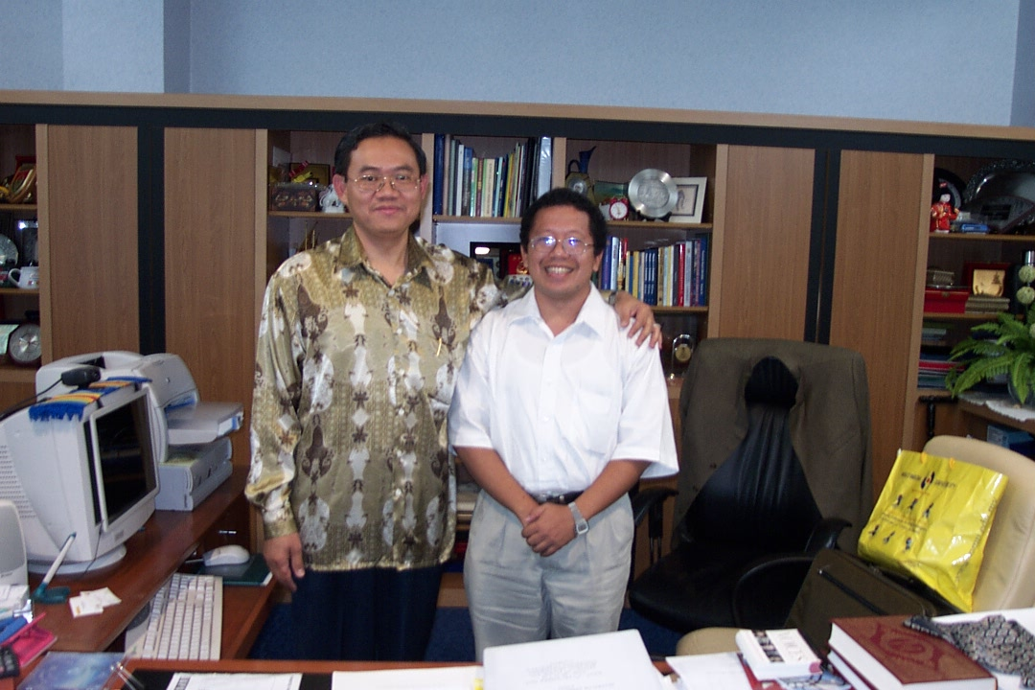
Visit Multimedia University (MMU), Cyberjaya, Malaysia

I must say Multi Media University (MMU) is an impressive university under the leadership of Prof. Ghauth Jasmon (Fellow 2002).

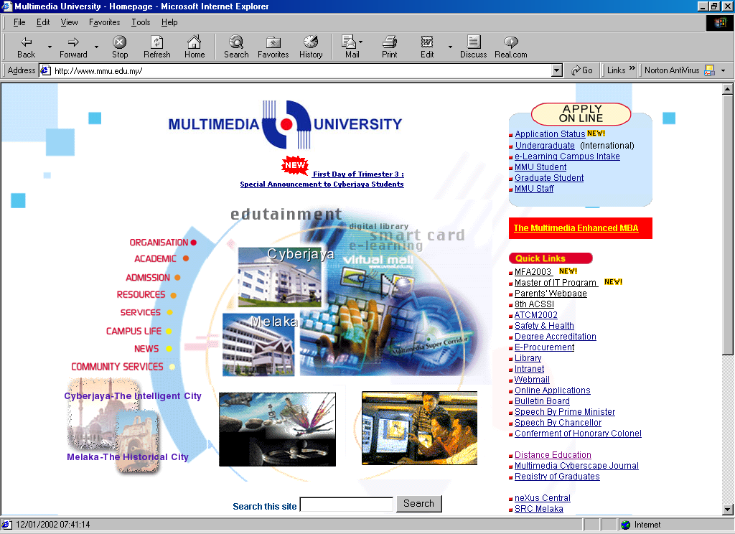
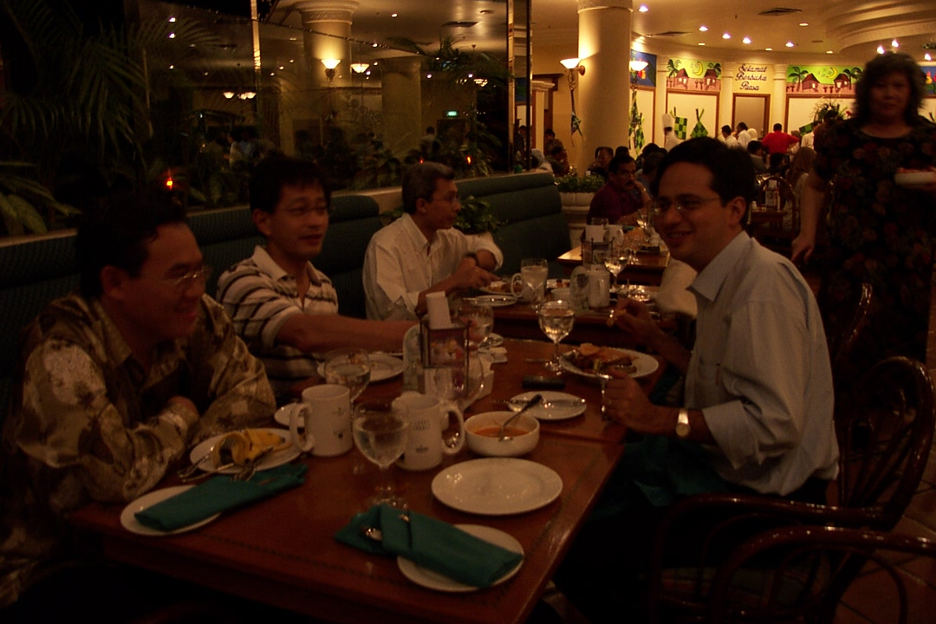
I had a change to see their impressive eGallery & as well as their intranet with the use of SmartCard as their main ID including for paying highway toll. Please feel free to check www.mmu.edu.my for more details.

At night, I meet three (3) Malaysian Eisenhower Fellow, namely, Prof. Ghauth Jasmon, Pak Judin & Pak Johan Raslan as shown in the picture ☺ ….

