Shift or Clash in Paradigm?

Are you convinced on the paradigm adopted by the ICT and telecommunication regulatory framework? If we look closely on most ICT & telecommunication regulatory framework, it will likely to assume that,

- Technology is expensive and complicated.
- Specialized skill needed to install and to operate the technology.

Such assumption is absolutely correct especially twenty years ago. Thus, it is very logical to see a common practice, such as,

- The infrastructure operated under government license.
- Investors may invest in the infrastructure in liberalized market.
- The infrastructure is build by vendor and contractors.
- Operators run the infrastructure.
- The infrastructure serves the users or customers.
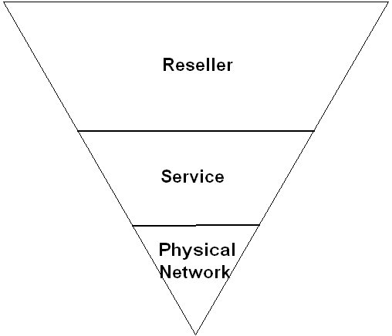
The telecommunication industry is very much structured, such that,

- Few physical network operators, normally the Incumbents. Licensed by the government.
- More service providers. Licensed by the government.
- A large number of resellers. No license is normally necessary, only agreement with the licensed operators.

Hopefully the incumbent does not exercise its power and distort the industry structure.

It is interesting to note that the current policy and regulatory framework implant a divide within, such as,

- Operators vs. users.
- Investors vs. users.
- Haves vs. the have not.

In a distorted environment, we will see more divide such as,

- One close to regulator vs. common people.
- One close to operator vs. common people.
- One close to political leaders vs. common people.

Fortunately, the information technology is becoming more affordable and user-friendlier. Thus, a clash in paradigm may occur as shown in the table.

 | Conventional | Future?
Technology | Expensive & Complex | Affordable & User-friendly
Specialized Skill | Yes | No
From | Licensed by Government | Common People
Invest by | Investor (Multinational) | Common People
Build by | Vendor & Contractor | Common People
Run by | Operator | Common People
For | User & Customer | Common People

Thus, it is not surprising to see shift in the industry structure, such as,

- Internet Café resells their bandwidth to their surrounding neighborhood and initiate a neighborhood network.
- VoIP integrates PBX of the main office to its branch offices and bypass any long distance charges.
- Offices, Neighborhood and communities bypass any Telco last mile infrastructure using low cost WiFi based equipments.
- Cost of VSAT equipments is getting lower, in the range of US$1500-2000/ground stations. Not surprising to see some will run a VSAT infrastructure service based outside the country.

Current advancement in ICT technology enables communities, offices, and resellers to act as unlicensed service providers and / or unlicensed physical network operators. Such shift creates a significant problem in the policy & regulatory framework that accept only licensed operators to run the network. No room for a community-based infrastructure; with homebrew equipments, from people, by people, for people. No room for WiFi based last mile. No room for VoIP based community network.

In Indonesia, it is common to see our WiFi and VoIP equipments taken by the government; some of us gone through interrogation by the police, some even have to stay in jail for several days. It is all part of the struggle to build a community-based infrastructure.

In reality, the bottom line is “money talk”. Unfortunately, common has limited amount of money to talk with. Keep in mind, a community or a neighborhood or a school may accumulate a large amount of money.

