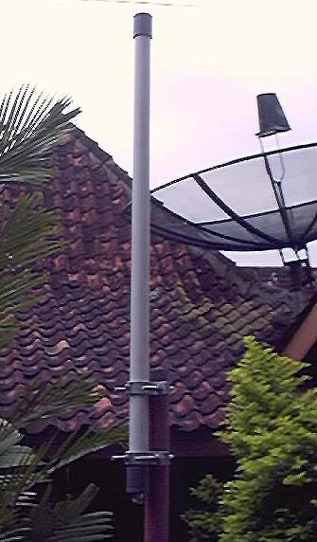 | 2.4 GHz 6 dBi Omnidirectional Antenna :  Specifications :  Electrical Specifications :  Frequency = 2400-2500 MHz  Gain = 6 dBi  Impedance = 50 Ohm  VSWR < 2.0:1 average  Polarization = Vertical  Mechanical Specifications :  Weight < 1.5 kg  Length = 75 cm  Radome Material = PVC  Mounting = 1.5" dia. mast max.  Ride The Wind Forever Free!  A Real HandMade, HomeBrewed 'with love' in Yogyakarta, Indonesia.  For the best quote, please contact : jbudisantosa@groundsys.com

