Brief Practical Installation Procedures for Wireless Internet Infrastructure

Onno W. Purbo
onno@indo.net.id

Aims & Objectives of This Manuscript
- Provides practical information on how to deploy your Wi-Fi Wireless Wide Area Network.
- Hopefully, will enable people with low cost Internet access, specially in developing countries.

Acknowledgement
- Indonesian Internet communities who fight for their freedom.
- International Development Research Center (IDRC) for supporting our work towards international communities.

Brief Overview of WiFi Based Wireless WAN
WiFi (Wireless Fidelity) is basically a generic term for wireless LAN equipments, also known as WLAN. It normally confirms the standard IEEE 802.11 family and, thus, supported by many vendors.

Why WiFi based Wireless Internet Infrastructure? There are few simple answers, i.e.,

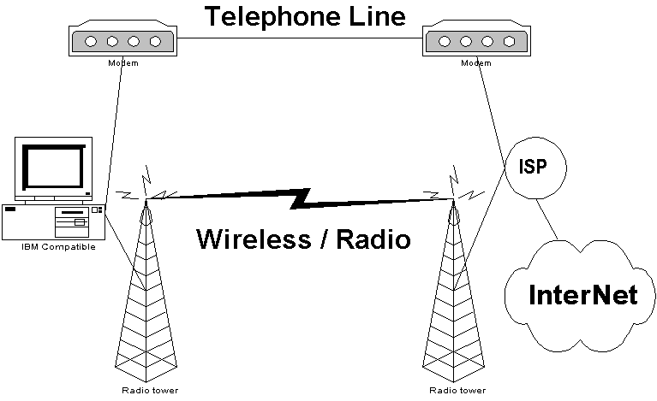
- Wireless for bypassing the need of costly & slow telephone line for accessing the Internet.
- Wireless is easy to deploy. It requires a much lower cost in the long run, rather than rely on Telco’s infrastructure.
- WiFi is basically Wireless LAN and, thus, it runs at higher speed 1-11Mbps if the standard IEEE 802.11b is used.
- Since IEEE 802.11b is an open standard, WiFi equipments can be obtained easily in the market & it costs only about 3-4 times a UTP LAN cards.

Having last mile telecommunication infrastructure solved, next best thing to do is sharing the access to the surrounding neighborhood & share the access fee to reduce the cost per subscribers.

WLAN Equipments for Outdoor usage.

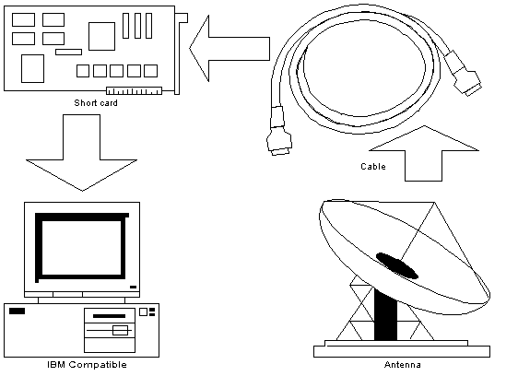
In some cases, the installation configuration can be varied quite significantly. Basically, we need four (4) major items to install WLAN for bypassing last mile Telco’s infrastructure, i.e.,

- PC router, it can be a Pentium I or Pentium II 64Mbyte RAM with Linux operating system for a more robust condition.
- WLAN Card, some people are using a PCI card with external antenna connector. For a much cheaper solution, my friends, such as sumaryo@netadsl.net, are using USB WLAN card with built-in antenna. Please note that not all WLAN card are suitable for outdoor use, some 3COM cards & Compex with no external antenna connection would be difficult for outdoor applications.
- Those who use PCI card with external antenna connector will require a pigtail and coaxial cable to connect the PCI card to external antenna. It would be much cheaper for you to use USB WLAN card, as these coaxial cables and expensive pig tail is no longer necessary. The total coaxial cable length should be kept short a RF signal loss at the coaxial cable may quite severe at such high frequency. We normally retain our coaxial cable less than 10 meters.
- An external antenna is needed for extending your communication distances. There are many 2.4GHz options. What you need is basically an external 2.4GHz antenna. If you wish to build your own 2.4GHz antenna, checking http://www.google.com and putting “Homebrew 2.4GHz antenna” may give a significant number of sites that gives you the requires knowledge on building your own 2.4GHz antenna.

For those who use a USB WLAN card with built-in 2.4GHz antenna, you may need to do several things to make your distance longer, i.e.,

- Make your USB WLAN card weatherproof.
- Make your USB cable weatherproof.
- Put your USB WLAN card in front of a parabolic reflector for higher antenna gain. You may use a used small parabolic reflector that normally used in satellite cable TV or you may build your own.

Preparing the Equipments

In this section, we will discuss item to be prepared to build a wireless neighborhood network. We basically need to prepare some hardware, such as,

Personal Computer for acting as a router
Wireless LAN (Wi Fi) card
Coaxial Cables
Antenna
UTP Hub for LAN

In most cases, we need to decide which operating system to be used at the router. I normally use Linux as my operating system, specially, Linux Mandrake as it is very easy to use and to install. When it runs in text mode, very minimal resources would be needed, and, thus, an old PC can always be used as the router. One can always use Windows as the operating system.

Hardware Preparation

The Personal Computer
If Linux used as the operating system of the router, personal computer (PC) needed for acting as the router / gateway between wireless network and neighborhood LAN would be something simple, such as,

Pentium II 166MHz
Memory 64Mbyte
Hard drive 3Gbyte

The Wireless LAN Card
Not all Wireless LAN card can be used for long distance / outdoor application, in fact, most of Wireless LAN vendors originally make wireless LAN cards for indoor applications. Fortunately, there are several type & version of wireless LAN (Wi-Fi) card that can be used for long distance applications. The one that can be used for outdoor / long distance applications would likely to have an external antenna connector.

Shown in the figure is an example of PCI Wireless LAN card. It has an SMA connector for external antenna.
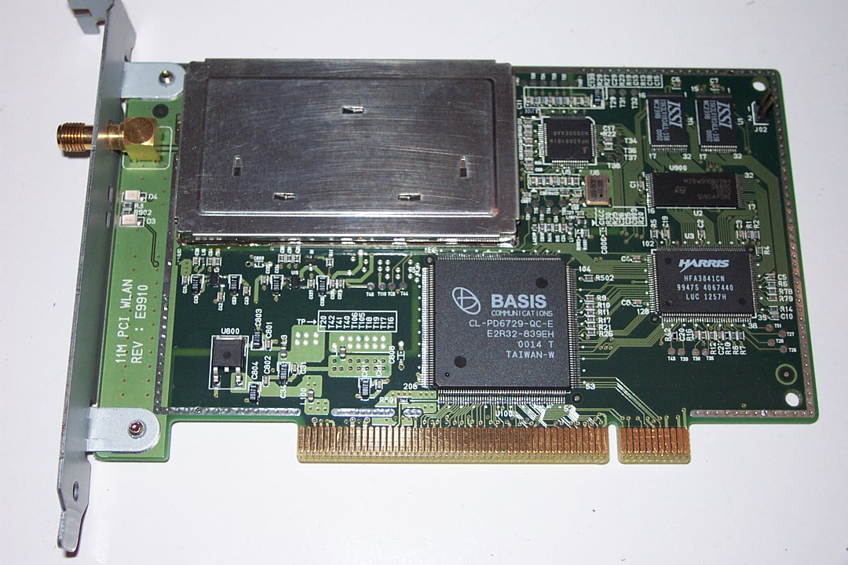

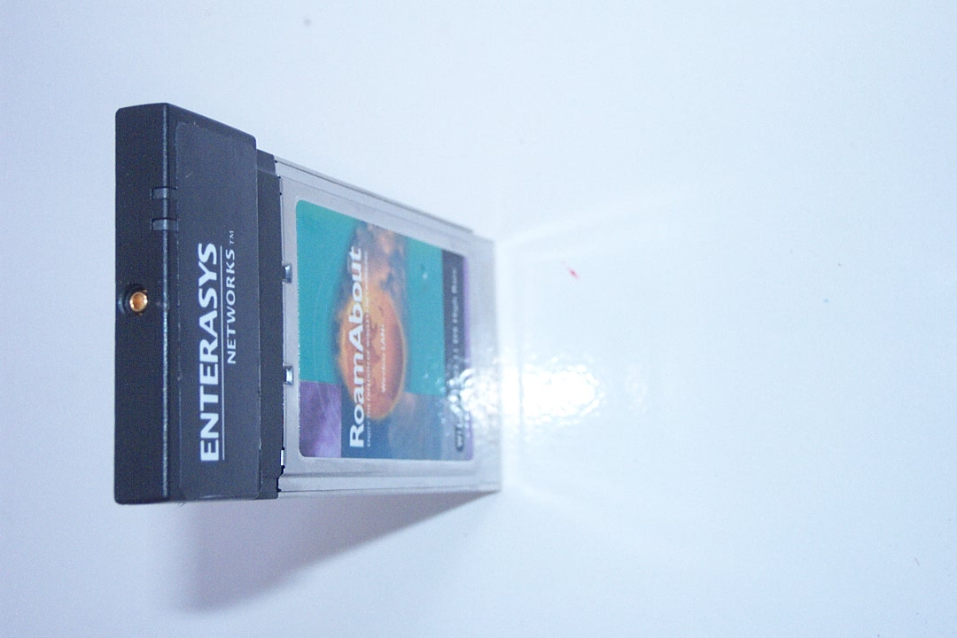
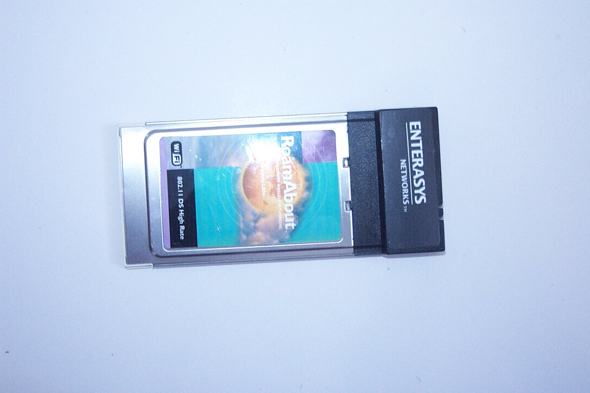
One of the most favouriteWLAN PCMCIA Card is the Lucent / Orinoco WaveLAN like cards. Drivers as well as application software to support such card in Linux is very easy to find. It is a PCMCIA type card and, thus, need a PCI adapter to be used in normal desktop.

One of the major drawback for using WaveLAN compatible card would be the connector for external antenna. As shown in the figure a small tiny connector is available. However, it would be very difficult for an ordinary engineer to make an adapter for such tiny connector. Well, we can always buy one for US$25-50. Unfortunately, it costs too much for most of us in developing countries.
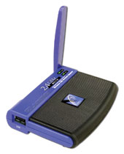
Based on my friends’, such as, sumaryo@netadsl.net, experience in implementing wireless LAN network. The total cost of implementation would be much cheaper to use USB Wireless LAN card rather than PCI or PCMCIA cards.

All we need is a long USB cable to the USB WLAN card, and make sure all are shielded for environment protection.

To make the transmission to reach a longer distance, we normally put a reflector in front of the USB WLAN card. A used Satellite Cable TV disc would be sufficient to extend the distance for a couple of kilometers.

Pigtail
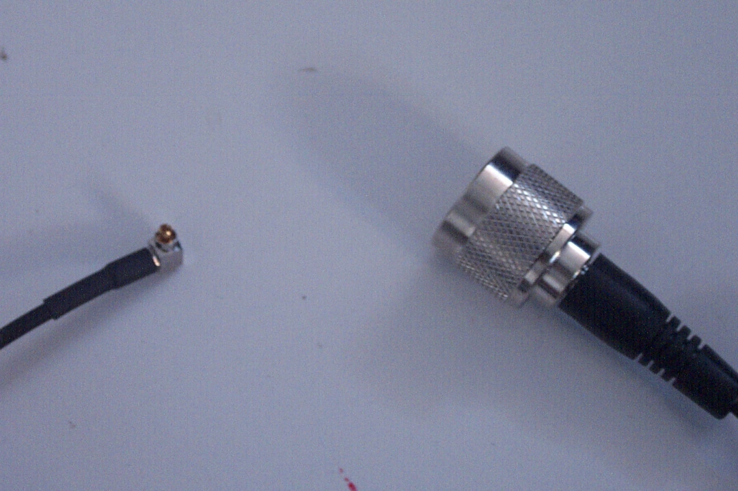
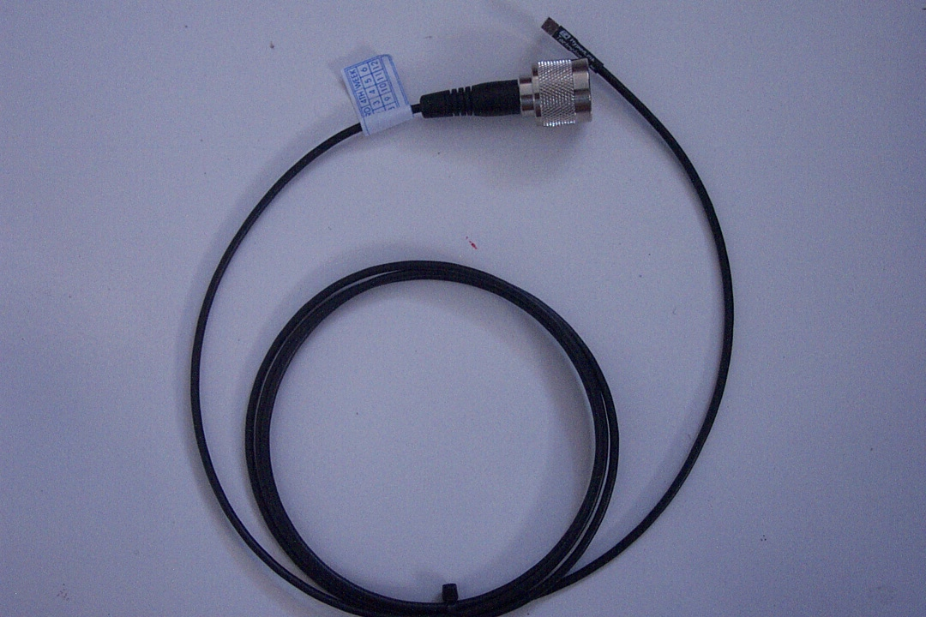
At 2.4GHz band, we normally use an N-type connector for our coaxial cable & antenna. To adapt different type of connector, we normally use a pigtail which is a short coaxial cable with two different coaxial connector at both end to adapt different type of connector needed at the WLAN card and the coaxial to the antenna.

Shown in the detailed picture, both end of the pigtail uses different type of connector. In the detailed picture, it shown the connector needed to connect to Orinoco type PCMCIA Wireless LAN card.

Antenna
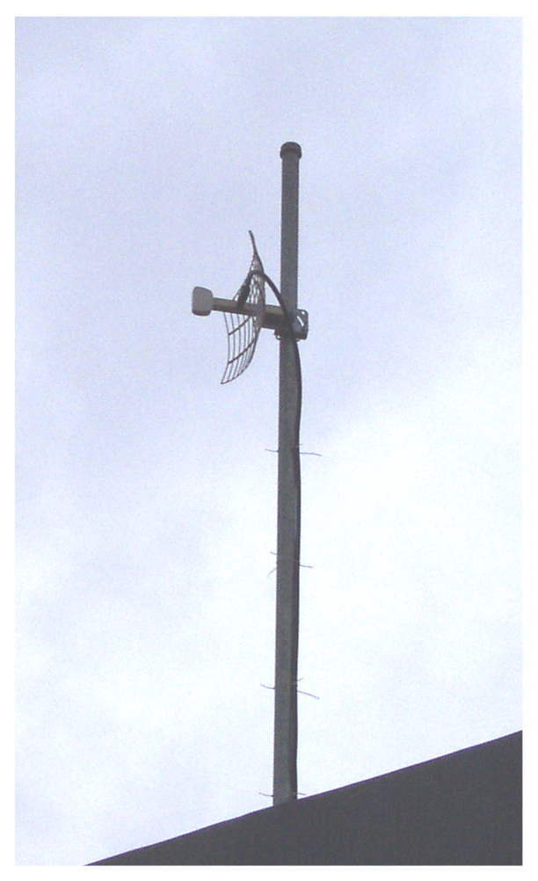
An external antenna is basically used to extend the distance. There are variety of Antennas can be used. Depending on the location / application, we normally need,

- At client side, a directional antenna, such as, parabolic antenna, yagi antenna, tin can antenna etc.

- At the access point, an omni-directional antenna or a sectoral antenna.

Detailed calculation of the link budget is needed to ensure the installed antenna would be sufficient to reach the required distance. A simple example for the System Operating Margin calculation can be found at http://www.ydi.com/calculation/som.php.

Access Point
At the Internet Service Provider (ISP), we normally need an Access Point (AP) to serve the wireless clients. The access point is basically serving as the hub for wireless client and a bridge to UTP LAN network. Thus, an Access Point (AP) will normally have both antenna as well as UTP port.

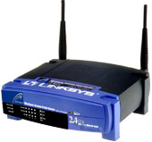
Some Access Points (AP) may have a more complex function, such as, DHCP server, Firewall, NAT, proxy server built-in into it. The Antenna is normally replaceable with an external antenna connected through a coaxial cable.

Some protections are normally provided at the Access Point (AP) to limit the access for certain MAC Address or IP address.

Software Preparation for the Router

For serious Router applications, I normally use Linux based machines. In particular, Linux Mandrake would be my favorite due to its easiness in installing the system and readily support most Wireless LAN cards. Linux Mandrake will normally detect the attach WLAN card & install the required driver. The card will be treated as a normal Ethernet card and do the routing normally.

Those who wish to use Microsoft Windows may always use Microsoft Windows operating system. Unfortunately, Microsoft Windows is not a recommended operating system for router applications.

WLAN installation in Linux

Preparing Linux box for WLAN operation in most cases are quite straight-forward. If latest Linux release is used, it most likely supports your old WLAN cards, especially, Orinoco cards, and will automatically detect and load the driver of the cards.

I am using Linux Mandrake most of the time, mainly due to its easiness in install & configure the system. Since most of the applications are ready in RPM format, it would be very easy to install software in Linux Mandrake. I would strongly recommend to use Linux for your 24 hours wireless Internet gateway.

Preparation Stage

- Prepare the computer that will be used as 24 hours wireless gateway to the Internet. Computer specification used at my home gateway is quite low, i.e.,
  - Pentium II 166MHz, 64MB RAM, HardDisk 3Gbyte.
  - Ethernet (LAN Card) with sufficient UTP cables.
  - Hub 10Mbps (I am using used hub, cost me about US$3-5).
  - Monitor, not necessary a good one. I am using video card S3 2Mbyte RAM.
  - CDROM drive (I am using 8x CD drive).
- Install the 2.4GHz antenna as well as its coaxial cable
- Prepare the WLAN card. I normally not insert the WLAN card during the software installation processes.
- I would like to suggest to use WLAN card that supported by PCMCIA driver in Linux. Summary of the WLAN card supported by PCMCIA driver in Linux last updated 2001/03/09 01:19:25 is listed below.
- If the card is not supported by PCMCIA, you may want to check several places that may carry the driver, such as,
  - http://www.magiclan.com (the official place of Samsung SWL 2000P).
  - http://www.linux-wlan.com
  - http://www.hpl.hp.com/personal/Jean_Tourrilhes/Linux/Linux.Wireless.drivers.html
  - http://www.hpl.hp.com/personal/Jean_Tourrilhes/Linux/Tools.html
- Coordinate with your ISP to get the required information on:
  - ESSID
  - IP address of our PC / WLAN card
  - IP address gateway at the ISP.
  - Channel / Frequency.
  - DNS Server.

Linux Installation of PC Gateway

- Nothing really special in installing Linux for 24 hours wireless gateway. Some security concern and minimal installation may be needed.
- I use the latest version of Linux Mandrake for most of my installation, as it is very easy to do and, thus, minimize my effort in educating others in using Linux.
- Since in most cases the gateway must provide the required support for its IntraNet, I normally install several required software, such as, wireless-tools, pcmcia-cs, iproute2, fetchmail, iptables, squid, postfix. If less supported card is used, development package and kernel-pcmcia may need to be installed for compiling the driver if needed.
- On a Pentium II 166MHz with 8x CD drive machine, we normally need approximately 45-60 minutes to complete the installation processes.
- After the completion of Linux installation processes, the local Ethernet card (UTP LAN) is activated and given the IP address of 92.168.0.1 to make it easy in performing Internet Connection Sharing.
- After the Linux installation processes, the WLAN card can now be inserted. If a common WLAN card is used, the operating system will normally detect the card & install the required driver. We may than configure the network for the card.

Configuring the WLAN

- A bit different than Windows environment with Graphical User Interface (GUI), in Linux, the configuration is performed in text mode. Most of the files needed to configure your WLAN are located at /etc/pcmcia. The needed files are config.opts, network.opts & wireless.opts. Note that some of the parameters in these three (3) files can be overlapped.
- Edit /etc/pcmcia/config.opts. Example of parameters to be added, can be,

  - For MAN/WAN connected to an Access Point (AP)/ISP
module “swldpc11_cs” opts “networkmode=1 essid=ispnet”

  - To increase transmission reliability, sometime it may help by reducing the MTU & increasing Access Point Density.
module “swldpc11_cs” opts “mtu=500 apdensity=3”

The complete parameters are listed below.

- Edit file /etc/pcmcia/network.opts. Configure IP address, gateway & DNS ISP, e.g., (please confirm it with your ISP)

*,*,*,*)
IF_PORT=""
BOOTP="n"
IPADDR="10.0.0.5"
NETMASK="255.255.255.0"
NETWORK="10.0.0.0"
BROADCAST="10.0.0.255"
GATEWAY="10.0.0.1"
DOMAIN="domain.org"
DNS_1="dns1.domain.org"
;;

- Edit file /etc/pcmcia/wireless.opts to configure the radio network. Please note that some parameters can be set in /etc/pcmcia/config.opts). An example is:

*,*,*,*)
INFO="SAMSUNG 11Mbps WLAN"
#ESSID (extended network name) : My Network, any
ESSID="test3"
# Operation mode : Ad-Hoc, Managed
MODE="Managed"
# Frequency or channel : 1, 2 (channel);2.422G, 2.46G (frequency)
CHANNEL="4"
# Bit rate : auto, 1M, 11M
RATE="auto"
# Encryption key : 4567-89AB-CD, s:password
KEY="883e-aa67-21 [1] key 5501-d0da-87 [2] key 91f5-3368-6b [3] key 2d73-31b7-96 [4]"
# Other iwconfig parameters : power off, ap 01:23:45:67:89:AB
IWCONFIG="power on"
;;

- Competing the editing of these three (3) files, you basically completed the configuration processes.
- Turn off the PC gateway. Insert the WLAN card into the existing PCI slot, and connect the external antenna.
- Please note that it would be safer to turn on the WLAN card with the antenna attached to reduce any reflection RF power that may ruin your card.

Monitoring WLAN Performance

To monitor WLAN performance, we use iwconfig provided in wireless-tools, such as

# iwconfig eth0

An example of the output is as follows

eth0 SAMSUNG WLAN ESSID:"ISPNET" Nickname:"warok"
Channel:6 Sensitivity:3/3 Mode:Managed
Access Point: 00:40:05:DE:27:EC
Bit Rate=11Mb/s RTS thr=150 B Fragment thr=2346 B
Encryption key:off
Power Management:off
Link quality:0/92 Signal level:27/153 Noise level:0/153
Rx invalid nwid:0 invalid crypt:0 invalid misc:0

Some of the point of interest are, Signal level (the higher the better), Link quality (the higher the better) & Noise level (the lower the better). Bit Rate might of interest especially if automatic speed is used.

For those who like to browse http://www.sourceforge.net, you might find a large collection of tools for monitoring your wireless equipments. I normally run Multi Router Traffic Grapher (MRTG) and IP Accounting Next Generation (ipac-ng) for monitoring my wireless gateway.

Setup Linux Based Wireless Gateway

To make our life a little bit easier, it is preferable to use Mandrake Control Center on your Mandrake desktop or Webmin at https://localhost:10000 to set up the gateway. Both are using Graphical User Interface (GUI) and, thus, very easy to use.

You may need to configure several services / devices to make sure the gateway can perform its functions, namely,

- Activate the WLAN card, give IP address
- Provide routing information.
- Set Proxy or Network Address Translation (NAT) function.

Radio Link Calculation

Unlike Indoor usage, ability to calculate radio link budget & distances is very critical if one wants to use Wireless LAN equipments for bypassing Telco’s last mile. Those who have very minimal radio knowledge might encounter some difficulties in doing it. Fortunately, http://www.ydi.com carries a simple radio link calculation accessible from the Internet. It includes all the formulas and, thus, anyone can always write their own routines in Excel. I would strongly suggest for accessing the site for playing with the radio link calculation.

There are several critical parameter needs to be calculate properly to make sure the system will correctly perform, namely,

- System Operating Margin (SOM), it correlates the transmitter power, type of antenna, length of coaxial cables and distance. We can make sure if our system has a sufficient power margin to reach such distance.
- Free Space Loss (FSL), loss in radio power in reaching certain distance.
- Fresnel Zone Clearance (FZC), to see the required antenna height needed to pass any obstacle.
- Antenna bearing, antenna down tilt, and antenna down tilt coverage radius are needed to know the exact point or area of your radio beaming into.

A power conversion calculation utility is also provided to convert dBm into Watt vice versa. The conversion is fairly simple, i.e.,

dBm = 30 + Log 10 (Watts)
Watts = 10^((dBm - 30)/10)
MilliWatts = 10^(dBm/10)

The calculations provided in YDI.COM is in miles and feet.

Free Space Loss (FSL) Calculation

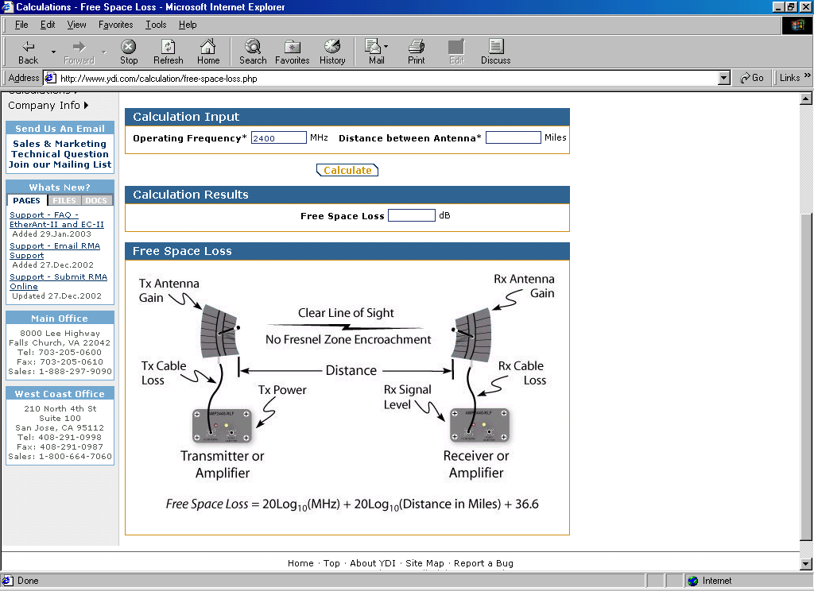
Shown in the figure is the Free Space Loss (FSL) calculation page provided by YDI.COM. As shown in the Figure, there are two (2) main parameters needed to calculate FSL, namely,

- Operating Frequency (in MHz)
- Distance Between Antennas (in Miles)

The output of the calculation is

- Free Space Loss (in dB)

The formula as shown clearly in the figure is

Free Space Loss (dB) = 20 Log10 (MHz) + 20 Log10 (Distance in Miles) + 36.6

We will normally see a Free Space Loss in the range of 100 dB for radio signal operating in 2.4GHz frequency traveling in one (1) km distance.

System Operating Margin (SOM) Calculation

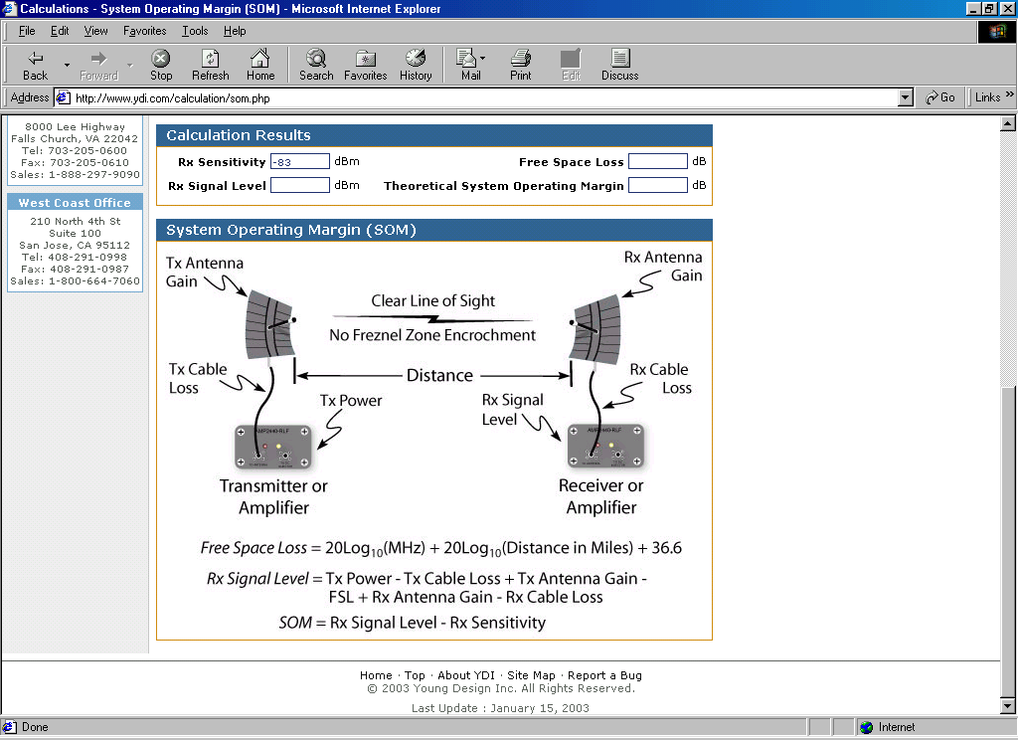
Shown in the Figure is the System Operating Margin (SOM) calculation page. It has many input parameters with three (3) main output, namely,

RX Signal Level (dBm)
Free Space Loss (dB)
Theoretical System Operating Margin (dB)

We need to make sure that we have about 10-15 dB of System Operating Margin (SOM) to give some space for any fading & multipath of the radio signal.

To be able to calculate these three (3) parameters, we need to provide the formula with data on Frequency (MHz), Distance (Miles), TX Power (dBm), WLAN card transmitter power normally about 30-100mW range, TX Cable Loss (dB), depending on type of cable & length. It would be better to restrict the length to less then 10 meter, TX Antenna Gain (dBi), Free Space Loss, RX Antenna Gain (dBi), RX Cable Loss (dB) and RX Sensitivity. Most of the data needed can be found in the manual or specification of the equipments. The calculation is fairly simple, namely,

SOM = RX Signal Level - RX Sensitivity.
RX Signal Level = TX Power - TX Cable Loss + TX Antenna Gain – FSL + RX Antenna Gain - RX Cable Loss.

Make sure we have SOM > 15dB to compensate any Fading or Multipath problems.

Antenna Systems

Coaxial Cable
Cable Type | Loss / 10 meter  (on 2.4GHz).
RG 8 | 3.3 dB
LMR 400 | 2.2 dB
Heliax 3/8” | 1.76 dB
LMR 600 | 1.7 dB
Heliax ½” | 1.2 dB
Heliax 5/8” | 0.71 dB

There are several type of coaxial cable can be used for passing your radio frequency signal to the antenna. The higher the frequency more signal loss will be experienced. Thus, one may select the low loss coaxial cable for a better performance. Shown on the table is list of power loss of several coaxial cables. We are normally trying to set 3dB as maximum loss at coaxial cable.

Antenna Polarization
There are two (2) type of antenna polarization, namely,

- Horizontal polarization. Normally found on directional antennas. Thus, can be used for Point To Point applications.
- Vertical polarization. Normally found on omnidirectional antennas. Thus, used mainly in Point to Multi Point applications.

Antenna Types
There are basically, three (3) type of antennas

- Omni directional antennas
- Sectoral antennas
- Directional antennas.

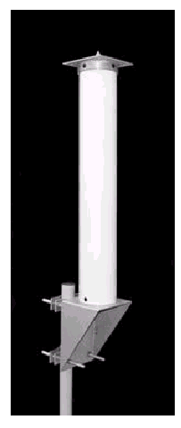
Omnidirectional antennas are basically a vertical antenna. It is vertically polarized. It is normally being used at access point. It radiates its Radio Frequency (RF) power 360 degree. The antenna gain is normally low around 8-12 dBi. Consequently, the area that can be covered by such antenna is quite low. In normal WiFi setup, it may cover around 4-5 km radius. Shown in the figure is the typical outdoor 2.4GHz antenna.

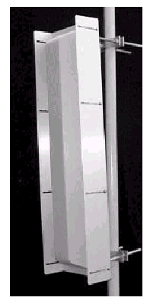
To increase the distance, we normally use sectoral antennas rather than omnidirectional antennas. The antenna gain is normally between 12-15 dBi higher than typical omnidirectional antennas. Consequently, it reaches longer distances. Unfortunately we have to compensate the advantage in distance with much narrow beam width. The beam width is normally between 90-180 degree as compared to 360 degree in omnidirectional antennas. Howerver, for a better Wireless Wide Area Network, it would be much better to use sectoral antennas.

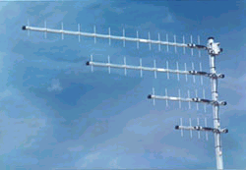
At client side, we normally use directional antennas. It has a much higher antenna gain as compared to omnidirectonal or sectoral antennas.

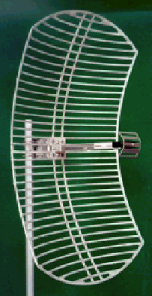
There are several type of directional antennas, some can even made by yourself at home. Try to use “homebrew 2.4GHz antennas” as keyword on google.com, you may find a lot of URLs to home made 2.4GHz antenna.

Most of serious wireless connection in Indonesia is using parabolic grid antenna at 19-24dBi antenna gain. It would be sufficient to reach the Access Point at about 8 km distance.

Designing the WiFi Wide Area Network
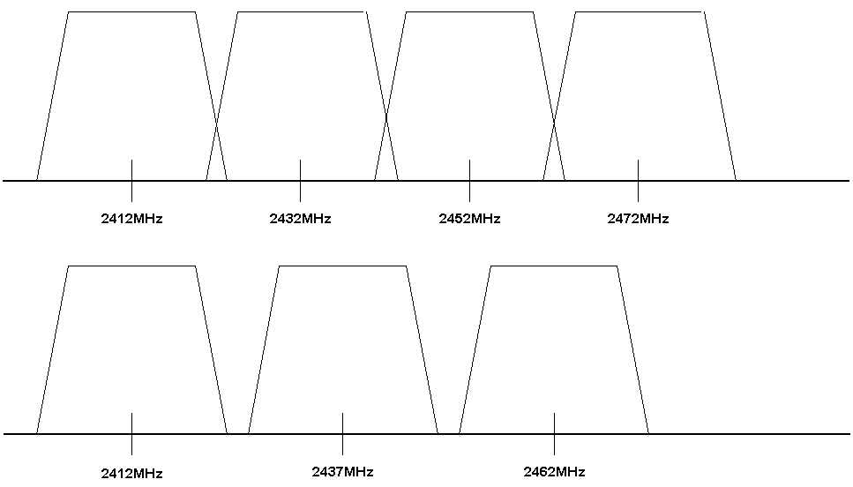
To properly design the Wireless Wide Area Network (WWAN), one needs to understand that the 2.4GHz frequency band is very limited. Depending on the country, we may use only few channels for the operation of the WiFi WLAN without interfering your neighbors. Thus, spatial frequency reuse would be a big issue in implementing WWAN.

Most of the equipment made for the US may only effective use three (3) frequencies, namely,

Channel 1 2.412GHz
Channel 6 2.437GHz
Channel 11 2.462GHz

At the same place so that we won’t interfere with our neighbors. In most of developing countries, we may use different orthogonal frequency configuration for four (4) channel configuration, such as

Channel 1 2.412GHz
Channel 5 2.432GHz
Channel 9 2.452GHz
Channel 11 2.472GHz

Knowing the frequency allocation and distances from previous calculation, we may now configure the Wireless Wide Area Network (WWAN).

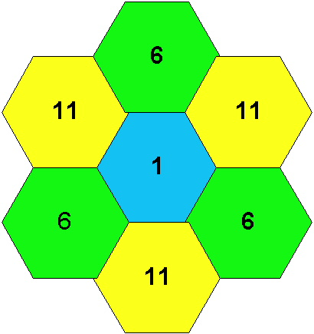
Shown in the figure is a design of Wirelesss Wide Area Network using omnidirectional antenna at the access point and using channel 1,6 and 11 only.

The three (3) different frequencies is represented by different colors and number. Assuming the transmission radius of an omnidirectional access point is in the range of 5 km, as shown in the figure, to cover an area of 30 km by 30 km we need about seven (7) towers.


When a sectoral antenna is used at the access point, we can put three (3) 120 degree beam width sectoral antenna on each tower. Each is running at different frequencies, namely, channel 1, 6 and 11.

Shown in the figure is the typical design of Wireless Wide Area Network served by Access Point with sectoral antenna running on three (3) different frequencies as represented by three (3) different color.

As shown clearly in the figure, to over a much larger area than the previous design, we need to install only three (3) towers with three (3) Access Points on each. Thus a significant reduction in cost is really apparent.

Internet connection to the Access Points can be made using different equipments, such as, WiFi on 5.8GHz etc.

