post tsunami disaster - Intermediate Action
initial proposal by
Gadjah Mada University Team
Query: nizam@ugm.ac.id

I. Background
Aceh and North Sumatra are two of the most devastated area strike by the worst ever tragedy caused by tsunami disaster. More than 92,000 death tolls and more than 200,000 refugees need immediate action by all concern with the humanity. Without understating the important problem of evacuating the thousands of death bodies that are still not evacuated, immediate and intermediate action to safe lives of the survivors are urgently required. Enormous efforts need to be done to address the problem. Concerned with the above gigantic task of helping the victims of the disasters we proposed the following action for the intermediate relief action.

II. Basic concept
The basic concept for intermediate action is to conduct the following actions:
- Swift yet well planned action to avoid further post-disaster casualties,
- Bringing the victims back to near-normal life
While at the same time planning for a more comprehensive solution for 4R – Rehabilitate, Restore, Relocate and Reconstruct can be prepared and conducted simultaneously.

III. Approach
The proposed approach is to evacuate and isolate disaster areas and victims are sheltered away from the calamity area and brought to near normal live as quickly as possible.
During the first 3 – 6 months victims are supported with shelter, food and water, health, security, social and economic life.

IV. Proposed plan and action
Basically the relieve action follows the following stages:
- emergency immediate-action
- inter mediate action
- restoration and rehabilitation
- development
A. Emergency (immediate) action
Emergency action includes the followings:
- evacuations of corpses,
- search and rescue of survivors,
- medical help,
- food and water distribution,
- sanitasion,
- temporary shelter,
- safety and security,
- trauma therapy.
Emergency action is conducted on the calamity site by medical personnels, volunteers, and military personnel. The aspects of emergency actions have been organized and managed by many parties such as the red cross/red crescent under the coordination of coordinating ministry of social affair, therefore will not be further elaborated.

B. Intermediate action
Intermediate action is aimed at survivors who mostly are in a traumatic condition, exhausted physically as well as mentally and desperately need a resting place to recover their physical and mental condition. The basic principle to accommodate the victims is to build temporary shelters outside the disaster region to allow them to recollect and rebuild their living. The shelters should form a community to assist victims to return to a normal live.

Intermediate action covers the following aspects:
- physical,
- health,
- religious, psychological & social, and
- economy.

- Physical aspect

Physical aspects to be prepared consist of basic facilities:
- shelter
- clean water
- sanitary/waste water

a. shelter
Instant shelters for victims should be constructed in clusters and located at open spaces some 5 to 10 km from the shoreline outside the disaster area. The location is selected based on the following considerations: first, the disaster area is prone to water borne and other diseases; second, victims are still traumatic with the disasters; third, by evacuating the disaster area clearing up and rehabilitation of the area can be conducted more easily.
By locating outside the disaster area, the victims are expected to recover from the traumatic experience while the disaster area can be cleared up and sanitized/disinfected to prevent from pest and disease wide spreading. Later on the disaster area can be rehabilitated.
Shelters are developed in clusters of instant shelters as schematically shown in Figures 1 and 2.
The instant shelter should have the following characteristics:
- easy and take a short time to construct,
- strong,
- healthy, and
- relatively cheap.
Each modular shelter can house 3 to 6 persons. The shelter should be flexible enough to grow as the need arise and if necessary and the situation permits can be developed into a permanent settlement.
Every 4 shelters is supported with 1 clean water tank and 1 public toilet with modular septic tank. A group of 10 – 40 shelters forms a spontaneous community (SC) or Rukun Tetangga Spontan (RTS) supported with a logistics, medical facility, and counsellor (religious/psycholog). Several SC forms a compound that is supported with a social and economic live. The social live is centered on Meunasah/small Mosque as the cultural characteristics of the local community. Social and psychological healing activities are centered on the Meunasah. A compound is also provided with an open space for sports and children playing ground.
There are several models of modular shelter that can be constructed using wood, bamboo, or corrugated steel frame while the walls are made of multiplex. Figures 3 to 6 show some of the alternative models. The cost to contruct one unit is between 5 to 10 million rupiah, while 1 toilet with tripikon-S septic tank system is around 3.5 million rupiah.

b. clean water
Each cluster of 4 household/shelter will be provided with one water tank using ground reservoir lined with plastic with 3 m³ capacity for 3 – 5 days supply. The clean water tank should be covered with plates to prevent from mosquito and other vectors. Water can be collected from rainfall and/or from water supply brought in from deep well source by mobile water tanks, since shallow wells are mostly contaminated. If necessary, chlorination can be provided for drinking water. In case mobile water tank could not reach the area, water from shallow dugwell with simple water purification technology can be set up as an alternative source of clean water.

c. waste water
To prevent infectious diseases from spreading, public sanitation is very important. Waste water treatment should be conducted using on-site system. Instant septic tank using a Tripikon-S that is made from 6 and 4 inches PVC pipes as shown in Figure 6.

2. Health Aspect
Health aspect covers public health facilities and medical support. Public health facilities include the following:
- drainage system to keep the area dry and avoid the spread of water-borne disease,
- public toilet equipped with instant sepctic tank (Tripikon-S),
- protect and maintain clean water from vectors,
- purify clean water if necessary,
- waste disposal by covering, composting and/or burning.

As for medical support, every 10 RTS will be supported with a field clinic with 1 medics and 2 para medics.

3. Religious, psychological and social support
Psychologically, victims are in a condition known as disaster traumatic stress response (DSTR) characterized by:
A. Self-Experience Stress Response:
- Dissociation; low self esteem due to feeling of failure; loss of hope, motivation, purpose of life; feeling of profound emptiness; feeling of being in “pieces”, “fall aparts”; absence of joy and pleasure; excessive seeking of security; self blaming; apathy; feeling of distruss; feeling distant from others; lack/low sexual desire; and feeling neglected and abondaned.
B. Emotional Stress Response:
- Fear; schock; anxiety; anger; sadness; depression; shame; phobias (of water, sand, wind, sea, waves, other related events/item to quake and tsunami).
C. Cognitive Stress Response:
- Mental confusion; concentration problems; memory impairment; denial of what’ve happened; repetitive vivid memory of trauma; decrease in decision making efficacy; attention problems; impoverished attention span.
D. Social/Interpersonal Stress Response
- Social isolation; increased interpersonal conflict; over-protective to spouse, children, friends & other significant others; avoidance behaviors to: beach, water, sand, boat, etc.
To help victims recover, they are in need of the following supports:
- Food - victims have to be fed properly
- Safety - reassure that they are safe! SaFe!! and SAFE!!!; Listen actively, do not judge!
- Personal and social comfort - reside them in the compound with other victims they know
- Support with someone who know their culture and can listen to their grievances (a local preacher/religious leader, a comforter),

Programs should be developed to assist them to recover to normal live. The following programs can be set up in the spontaneous compound:
- Engage victims in group, social and communal activities;
- religious activities such as mass congregation, quran recitals;
- Engage them with activities that will occupy their time, and memory away from the disaster such as: sports, indoor and outdoor family activity, and avoid things that remind victims with the disasters.
- Supply them with light reading materials (age appropriate); avoid readings with disaster exposures.
- Supply them with basic school supplies: paper, pencil, chalk, crayon, erasers, blackboard, drawing books, coloured papers, glue, notebooks.
- Provide school children with school textbooks WHEN THEY ARE READY.
To conduct those activities, each compound is provided with a Meunasah as a center for social and religious activity and open spaces. Meunasah can also be used for temporary school for children.

Trauma may last only one week or two. But for some psychologically fragile individuals this can last for months or even longer. In that case, psychologists or psychiatrist have to be sought for a special treatment. Therefore a counsellor, psychologist or psychiatrist should be provided to support each spontaneous compound.

To bring to near normal live, each compound should also form a kind of organization consisting of one leader and two assistances.
4. Economic Support

During the first few weeks economic needs should be fully supported from outside. Gradually, victims should be engaged with economic activities such as: handicraft, making home industry, planting vegetables, gardening, poultry, fishery, etc. based on their interest and skill. A temporary market place can be established later on after they are ready. An economic program should be prepared to support and bring victims back to fully recovered normal and productive live such as through small enterprises and soft loan schemes.

Budget estimates (unit cost)

No | Item | Rupiah | US$
A | Infrastructure
1. | Cost of one shelter | 6,000,000 | 700
2. | Cost of clean water & sanitation support for 4 shelters | 8,000,000 | 900
3. | Cost of a Meunasah for 40 shelters | 24,000,000 | 2,800
4. | Cost of a clinic for 40 shelters | 30,000,000 | 3,350
5. | Open space, road & infrastructure | 10,000,000 | 1,120
B | Support (per day)
1. | Food & water per person | 20,000 | 2
2. | Health, psychology & social support per person | 20,000 | 2
3. | Education per household/month | 100,000/month  3,350/day | 12

Budget estimate per cluster of 40 shelters (around 120 persons)
No | Item | Rupiah | US$
A | Infrastructure
1. | Cost of shelters | 240,000,000 | 28,000
2. | Cost of clean water & sanitation | 80,000,000 | 9,000
3. | Cost of a Meunasah for 40 shelters | 24,000,000 | 2,800
4. | Cost of a clinic for 40 shelters | 30,000,000 | 3,350
5. | Open space, road & infrastructure | 10,000,000 | 1,120
 | Sub Total A | 384,000,000 | 44,270
B | Support (per month)
1. | Food & water | 72,000,000 | 8,100
2. | Health, psychology & social support per person | 72,000,000 | 8,100
3. | Education | 4,050,000 | 450
 | Sub Total B | 148,050,000 | 16,650
 | Total A + B | 532,000,000 | 60,920

Cost of deployment to setup 1 cluster of 40 shelters
No | Item |  | Rupiah | US$
A | Labors & supervisors
1. | Labors (5 person-day/shelter) | 200 person-day | 20,000,000 | 2,250
2. | Supervisor | 12 person-day | 6,000,000 | 625
 | Sub Total |  | 26,000,000 | 2,875
B | Live & community support (per month)
1. | Doctor/Physician | 1 person | ??? | ???
2. | Religious comforter/ psychologist | 1 person | ??? | ???
3. | Para medics | 2 persons | ??? | ???
 | Sub Total B

Figure 1. Basic Concept of intermediate action
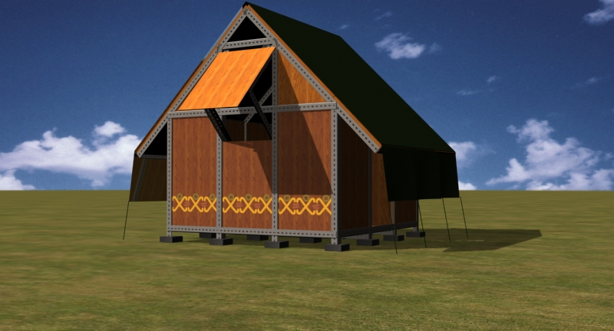
Figure 2. Sample of a shelter module

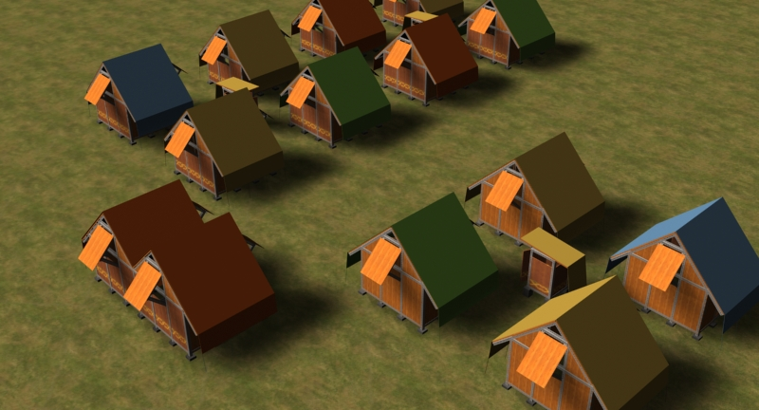

Figure 3. Spontaneous Community

